A Real Time and Interactive Dashboard in Tourism Industry

**Design Document**

By

Junyu Zhou 592115508

Yawei Li 592115518

Department of Software Engineering,

College of Arts, Media and Technology,

ChiangMai University

Project Advisor



Table of Contents

1. Document History 6

2. Introduction 8

2.1 Purpose 8

2.2 Intended Audience and Reading Suggestions 8

2.3 Project Scope 9

2.4 Acronyms 9

3. System Architecture 10

4. Detail Design (UML Diagram) 12

4.1 Component Diagram 12

4.2 Class Diagram 14

Class diagram overview of whole system 14

CD-01 App 16

CD-02 Home 17

CD-03 Register 19

CD-04 Login 21

CD-05 AdminLogin 24

CD-06 Admin 25

CD-07 Accounts 28

CD-08 Dashboard 30

CD-09 User Profile 33

CD-10 EditProfile 35

CD-11 Summary 40

CD-12 SparkLine 41

CD-13 LineChart 44

CD-14 BarChart 46

CD-15 StackedChart 48

CD-16 DataService 50

CD-17 UserService 54

CD-18 Mongo 57

CD-19 DataProvider 64

CD-20 Log 69

CD-21 Hotel 71

CD-22 View 74

CD-23 HeatMap 76

CD-24 Word-Cloud 78

4.3 ER Diagram 80

4.4 Sequence Diagram 81

5. User Interface Design 90

5.1 Web Application UI 90

5.1.1 W-UI01-Homepage 90

5.1.2 W-UI02-Super admin login 91

5.1.3 W-UI03-Register 92

5.1.4 W-UI04-Admin Login 93

5.1.5 W-UI05-Add accounts 94

5.1.6 W-UI06-Dashboard 95

5.1.7 W-UI07-User profile page 96

5.1.8 W-UI08-Edit username page 97

5.1.9 W-UI09-Edit password page 98

5.1.10 W-UI10- All users view comments 99

5.1.11 W-UI11- Admin writes comments 100

5.1.12 W-UI12- Super admin views system log 101

5.1.13 W-UI13- View the word-cloud of data 102

5.1.14 W-UI14- View the heatmap of data. 103

5.1.15 W-UI15- View the comments by sentiment. 104

6. List of Figures 106

# 1. Document History

|  |  |  |  |  |  |
| --- | --- | --- | --- | --- | --- |
| History | Status | Date | Viewable | Editable | Responsible |
| Project-DesignDocument_v1.docx  Create:  - Document History  - Introduction  - System Architecture  - Detail Design  - User Interface Design | Draft | 17, July 2019 | ZJY, LYW,  AJP | ZJY, LYW | ZJY,  LYW |
| Project-DesignDocument_v2.docx  Modify:  - Detail Design  - User Interface Design | Draft | 22, Aug 2019 | ZJY, LYW,  AJP | ZJY, LYW | ZJY,  LYW |
| Project-DesignDocument_v3.docx  Modify:  - Detail Design  - User Interface Design | Final | 28, Nov 2019 | ZJY, LYW,  AJP | ZJY, LYW | ZJY,  LYW |

ZJY = Junyu Zhou

LYW = Yawei Li

AJP = Dr. Pree Thiengburanathum

# 2. Introduction

## 2.1 Purpose

The purpose of the software design document (SDD) is to design the detailed structure of the system according with the software requirement specification (SRS). It intended to help stakeholders in the project understands the detailed design of the system using class diagrams, sequence diagrams, and user interface designs.

## 2.2 Intended Audience and Reading Suggestions

**2.2.1 Intended Audience**

This software requirement specification will benefit to audiences as followed:

**Development Team**

The software requirement specification will help everyone in developer team has the same understanding or overall scope of the project.

The software requirement specification will help the developer to verify and validate the software product that match with the requirements in this document or not.

The software requirement specification will help developers to develop project more efficiency.

The software requirement specification will be required when some changing occur. Developer will know where get effect and know where to change.

**User**

The software requirement specification will help the user to know the process of the software product.

User can check that the requirements in software requirement specification match with their requirement or not.

The software requirement specification can help the user to discuss with developers easier.

## 2.3 Project Scope

A real time and interactive dashboard in tourism industry is a web-based application. It is for decision maker to do the easy statistics of mess data in a real time way. For decision maker to manage and keep tracks all the data.

## 2.4 Acronyms

SRS = Software Requirement Specification SDD Software Design Document

UI = User Interface

DD = Development Diagram

CD= Class Diagram

ER= Entity Relationship Diagram

# 3. System Architecture

(On the next page)

Figure : System Architecture

The system consists of clients and server. For the client, there is a part, the web application. The web application that used by users will send and receive data from webserver in JSON format. The server itself store and retrieve data from the database.

We are using pusher components, which could transfer the data two-way duple

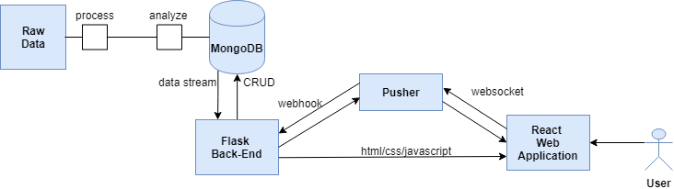

# 4. Detail Design (UML Diagram)

## 4.1 Component Diagram

(On the next page)

## 

Figure : Component Diagram

## 4.2 Class Diagram

## Class diagram overview of whole system

(On the next page)

Figure : Class diagram

## CD-01 App

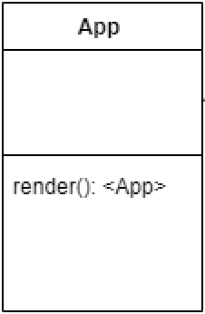

Figure : App class

**Method Detail:**

|  |  |
| --- | --- |
| **ID** | 1 |
| **Name** | render () |
| **Parameters** | - |
| **Description** | It is the main class of system |
| **Returns** | <App> |

## CD-02 Home

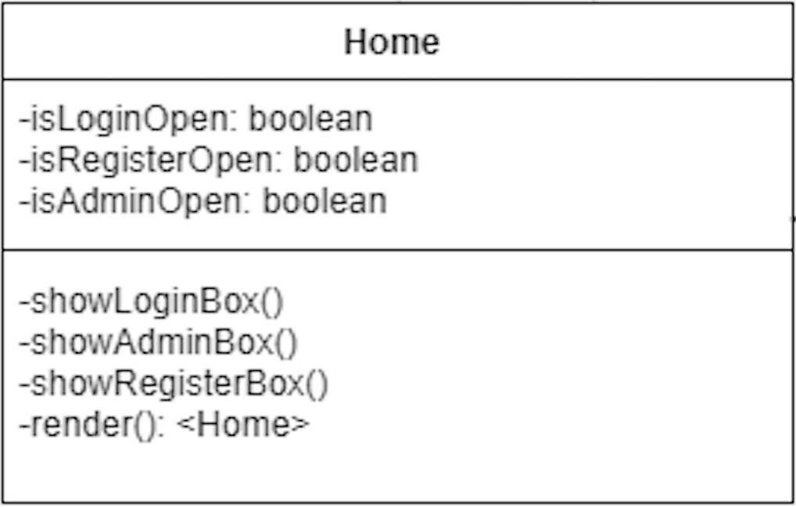

Figure : Home class

**Field Summary:**

|  |  |  |  |  |
| --- | --- | --- | --- | --- |
| ID | Modifier | Type | Field | Description |
| 1 | Default | boolean | isLoginOpen | Check if system displays login interface. |
| 2 | Default | boolean | isRegisterOpen | Check if system displays register interface. |
| 3 | Default | boolean | isAdminOpen | Check if system displays admin interface. |

**Method Detail:**

|  |  |
| --- | --- |
| **ID** | 1 |
| **Name** | showLoginBox () |
| **Parameters** | - |
| **Description** | It is used to show login box. |
| **Returns** | - |

|  |  |
| --- | --- |
| **ID** | 2 |
| **Name** | render () |
| **Parameters** | - |
| **Description** | It is used to render component |
| **Returns** | <Home> |

|  |  |
| --- | --- |
| **ID** | 3 |
| **Name** | showRegisterBox () |
| **Parameters** | - |
| **Description** | It is used to show register box. |
| **Returns** | - |

|  |  |
| --- | --- |
| **ID** | 4 |
| **Name** | showAdminBox () |
| **Parameters** | - |
| **Description** | It is used to show admin box. |
| **Returns** | - |

## CD-03 Register

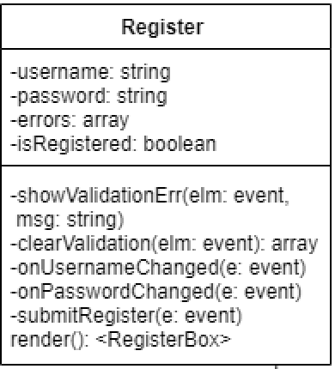

Figure : Register class

**Field Summary:**

|  |  |  |  |  |
| --- | --- | --- | --- | --- |
| ID | Modifier | Type | Field | Description |
| 1 | Default | String | username | The username of account |
| 2 | Default | String | password | The password of account |
| 3 | Default | array | errors | The array of errors |
| 4 | Default | boolean | isRegistered | The boolean to judge if register |

**Method Detail:**

|  |  |
| --- | --- |
| **ID** | 1 |
| **Name** | showValidationErr () |
| **Parameters** | elm: event, msg: string |
| **Description** | It is used to show validation message |
| **Returns** | - |

|  |  |
| --- | --- |
| **ID** | 2 |
| **Name** | clearValidation () |
| **Parameters** | elm: event |
| **Description** | It is used to remove validation message |
| **Returns** | array |

|  |  |
| --- | --- |
| **ID** | 3 |
| **Name** | onUsernameChanged () |
| **Parameters** | e: event |
| **Description** | It is used to listen username change. |
| **Returns** | - |

|  |  |
| --- | --- |
| **ID** | 4 |
| **Name** | onPasswordChanged () |
| **Parameters** | e: event |
| **Description** | It is used to listen password change. |
| **Returns** | - |

|  |  |
| --- | --- |
| **ID** | 5 |
| **Name** | submitRegister () |
| **Parameters** | e: event |
| **Description** | It is used to submit register form. |
| **Returns** | - |

|  |  |
| --- | --- |
| **ID** | 6 |
| **Name** | render () |
| **Parameters** | elm: event, msg: string |
| **Description** | It is used to render component. |
| **Returns** | <RegisterBox> |

## CD-04 Login

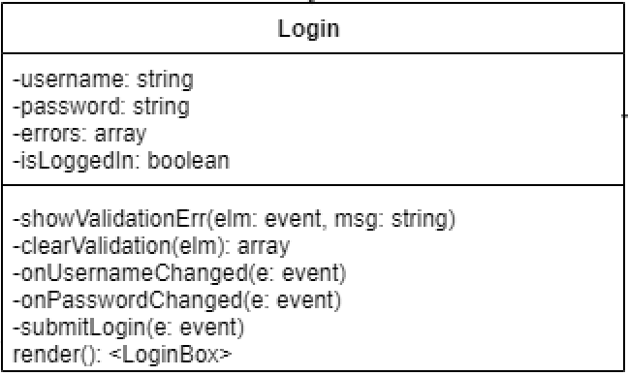

Figure : Login class

**Field Summary:**

|  |  |  |  |  |
| --- | --- | --- | --- | --- |
| ID | Modifier | Type | Field | Description |
| 1 | Default | String | username | The username of account |
| 2 | Default | String | password | The password of account |
| 3 | Default | array | errors | The array of errors |
| 4 | Default | boolean | isLoggedln | The boolean to judge if login |

**Method Detail:**

|  |  |
| --- | --- |
| **ID** | 1 |
| **Name** | showValidation () |
| **Parameters** | elm: event, msg: string |
| **Description** | It is used to show validation |
| **Returns** |  |

|  |  |
| --- | --- |
| **ID** | 2 |
| **Name** | clearValidationt () |
| **Parameters** | elm: |
| **Description** | It is used to remove validation |
| **Returns** | array |

|  |  |
| --- | --- |
| **ID** | 3 |
| **Name** | onUsernameChanged () |
| **Parameters** | e: event |
| **Description** | It is used to listen username change. |
| **Returns** | - |

|  |  |
| --- | --- |
| **ID** | 4 |
| **Name** | onPasswordChanged () |
| **Parameters** | - |
| **Description** | It is used to listen password change. |
| **Returns** | <LoginBox> |

|  |  |
| --- | --- |
| **ID** | 5 |
| **Name** | submitLogin () |
| **Parameters** | e: event |
| **Description** | It is used to submit login request |
| **Returns** |  |

|  |  |
| --- | --- |
| **ID** | 6 |
| **Name** | render () |
| **Parameters** | e: event |
| **Description** | It is used to render component. |
| **Returns** |  |

## CD-05 AdminLogin

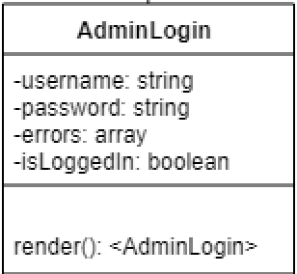

Figure : AdminLogin class

**Field Summary**

|  |  |  |  |  |
| --- | --- | --- | --- | --- |
| ID | Modifier | Type | Field | Description |
| 1 | Default | string | username | The username of account |
| 2 | Default | string | password | The password of account |
| 3 | Default | array | errors | The array of errors |
| 4 | Default | boolean | isLoggedln | The boolean to judge if login |

**Method Detail:**

|  |  |
| --- | --- |
| **ID** | 1 |
| **Name** | render () |
| **Parameters** | - |
| **Description** | It is used to render component. |
| **Returns** | <AdminLogin> |

## CD-06 Admin

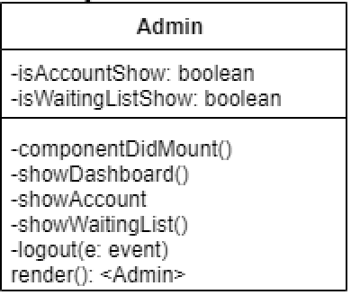

Figure : Admin class

**Field Summary**

|  |  |  |  |  |
| --- | --- | --- | --- | --- |
| ID | Modifier | Type | Field | Description |
| 1 | Default | boolean | isAccountShow | The boolean to judge if account is showing |
| 2 | Default | boolean | isWaitingListShow | The boolean to judge if waiting list is showing |

**Method Detail:**

|  |  |
| --- | --- |
| **ID** | 1 |
| **Name** | componentDidMount () |
| **Parameters** | - |
| **Description** | It is used to load data from local storage after all components are rendered. |
| **Returns** | - |

|  |  |
| --- | --- |
| **ID** | 2 |
| **Name** | showDashboard () |
| **Parameters** | - |
| **Description** | It is used to show dashboard. |
| **Returns** | - |

|  |  |
| --- | --- |
| **ID** | 3 |
| **Name** | showAccount () |
| **Parameters** | - |
| **Description** | It is used to show account. |
| **Returns** | - |

|  |  |
| --- | --- |
| **ID** | 4 |
| **Name** | showWaitingList () |
| **Parameters** | - |
| **Description** | It is used to show waiting list. |
| **Returns** | - |

|  |  |
| --- | --- |
| **ID** | 5 |
| **Name** | logout () |
| **Parameters** | e: event |
| **Description** | It is used to logout from system. |
| **Returns** | - |

|  |  |
| --- | --- |
| **ID** | 6 |
| **Name** | render () |
| **Parameters** | - |
| **Description** | It is used to render component. |
| **Returns** | <Admin> |

## CD-07 Accounts

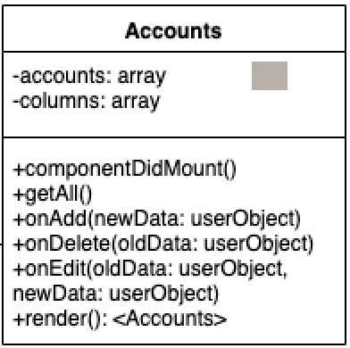



Figure : Accounts class

**Field Summary**

|  |  |  |  |  |
| --- | --- | --- | --- | --- |
| ID | Modifier | Type | Field | Description |
| 1 | Default | array | accounts | The array of accounts |
| 2 | Default | array | columns | The array of columns |

**Method Detail:**

|  |  |
| --- | --- |
| **ID** | 1 |
| **Name** | componentDidMount () |
| **Parameters** | - |
| **Description** | It is used to load data from local storage after all components are rendered. |
| **Returns** | - |

|  |  |
| --- | --- |
| **ID** | 2 |
| **Name** | getAll () |
| **Parameters** | - |
| **Description** | It is used to get all accounts |
| **Returns** | - |

|  |  |
| --- | --- |
| **ID** | 3 |
| **Name** | onAdd () |
| **Parameters** | newData: userObject |
| **Description** | It is used to listen add change. |
| **Returns** | - |

|  |  |
| --- | --- |
| **ID** | 4 |
| **Name** | onDelete () |
| **Parameters** | oldData: userObject |
| **Description** | It is used to listen delete change. |
| **Returns** |  |

|  |  |
| --- | --- |
| **ID** | 5 |
| **Name** | onEdit () |
| **Parameters** | oldData: userObject, newData: userObject |
| **Description** | It is used to listen edit change. |
| **Returns** | - |

|  |  |
| --- | --- |
| **ID** | 6 |
| **Name** | render () |
| **Parameters** | - |
| **Description** | It is used to render component. |
| **Returns** | <Admin> |

## CD-08 Dashboard

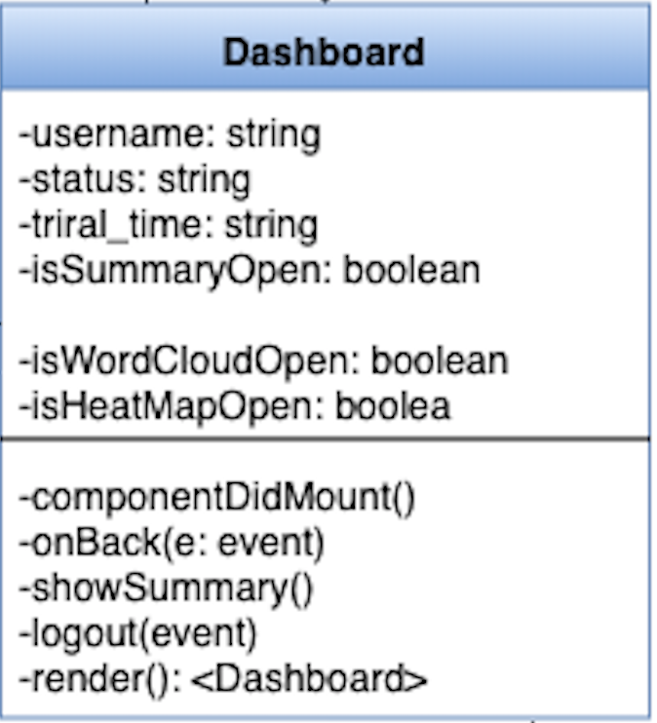

Figure : Dashboard class

**Field Summary**

|  |  |  |  |  |
| --- | --- | --- | --- | --- |
| ID | Modifier | Type | Field | Description |
| 1 | Default | string | username | The username of account |
| 2 | Default | string | password | The password of account |
| 3 | Default | string | triral_time | The trial time of account |
| 4 | Default | boolean | isSummaryOpen | The boolean to judge if summary page is opening. |
| 5 | Default | boolean | isWordCloudOpen | The boolean to judge if word cloud is opening |
| 6 | Default | boolean | isHeatMapOpen | The boolean to judge if heat map is opening |

**Method Detail:**

|  |  |
| --- | --- |
| **ID** | 1 |
| **Name** | componentDidMount () |
| **Parameters** | - |
| **Description** | It is used to load data from local storage after all components are rendered. |
| **Returns** | - |

|  |  |
| --- | --- |
| **ID** | 2 |
| **Name** | onBack () |
| **Parameters** | e: event |
| **Description** | It is used to listen back button is clicked. |
| **Returns** | - |

|  |  |
| --- | --- |
| **ID** | 3 |
| **Name** | showSummary () |
| **Parameters** | - |
| **Description** | It is used to show summary. |
| **Returns** | - |

|  |  |
| --- | --- |
| **ID** | 4 |
| **Name** | logout () |
| **Parameters** | event |
| **Description** | It is used to log out and remove data from local storage. |
| **Returns** | - |

|  |  |
| --- | --- |
| **ID** | 5 |
| **Name** | render () |
| **Parameters** | - |
| **Description** | It is used to render component. |
| **Returns** | <Dashboard> |

## CD-09 User Profile

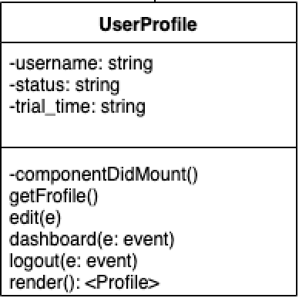

Figure : User Profile class

**Field Summary**

|  |  |  |  |  |
| --- | --- | --- | --- | --- |
| ID | Modifier | Type | Field | Description |
| 1 | Default | string | username | The username of account |
| 2 | Default | string | status | The status of account |
| 3 | Default | string | trial_time | The trial time of account |

**Method Detail:**

|  |  |
| --- | --- |
| **ID** | 1 |
| **Name** | componentDidMount () |
| **Parameters** | - |
| **Description** | It is used to load data from local storage after all components are rendered. |
| **Returns** | - |

|  |  |
| --- | --- |
| **ID** | 2 |
| **Name** | getProfile () |
| **Parameters** | - |
| **Description** | It is used to get user profile |
| **Returns** | - |

|  |  |
| --- | --- |
| **ID** | 3 |
| **Name** | edit () |
| **Parameters** | e |
| **Description** | It is used to edit account information |
| **Returns** | - |

|  |  |
| --- | --- |
| **ID** | 4 |
| **Name** | dashboard () |
| **Parameters** | e: event |
| **Description** | It is used to display dashboard |
| **Returns** | - |

|  |  |
| --- | --- |
| **ID** | 5 |
| **Name** | logout () |
| **Parameters** | e: event |
| **Description** | It is used to log out from system |
| **Returns** | - |

|  |  |
| --- | --- |
| **ID** | 6 |
| **Name** | render () |
| **Parameters** | - |
| **Description** | It is used to render component. |
| **Returns** | <Profile> |

## CD-10 EditProfile

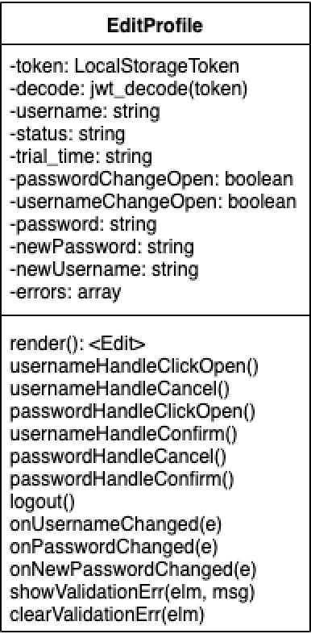

Figure : Edit Profile class

**Field Summary**

|  |  |  |  |  |
| --- | --- | --- | --- | --- |
| ID | Modifier | Type | Field | Description |
| 1 | Default | LocalStorageToken | token | User identify in the local storage |
| 2 | Default | jwt_decode | decode | It is used to decode |
| 3 | Default | string | username | The username of account |
| 4 | Default | string | status | The status time of accounts |
| 5 | Default | string | trial_time | The trial time of account |
| 6 | Default | boolean | passwordChangeOpen | It is used to judge if password change |
| 7 | Default | boolean | usernameChangeOpen | It is used to judge if username change |
| 8 | Default | string | password | The password of account |
| 9 | Default | string | newUsername | The new username of account |
| 10 | Default | string | newPassword | The new password of account |
| 11 | Default | array | errors | The array of errors |

**Method Detail:**

|  |  |
| --- | --- |
| **ID** | 1 |
| **Name** | render () |
| **Parameters** | - |
| **Description** | It is used to render component |
| **Returns** | <Edit> |

|  |  |
| --- | --- |
| **ID** | 2 |
| **Name** | usernameHandleClickOpen () |
| **Parameters** | - |
| **Description** | It is used to listen if username handle clicks open |
| **Returns** | - |

|  |  |
| --- | --- |
| **ID** | 3 |
| **Name** | usernameHandleCancel () |
| **Parameters** | - |
| **Description** | It is used to listen if username handle clicks cancel |
| **Returns** | - |

|  |  |
| --- | --- |
| **ID** | 4 |
| **Name** | passwordHandleClickOpen () |
| **Parameters** | - |
| **Description** | It is used to listen if password handle clicks open |
| **Returns** | - |

|  |  |
| --- | --- |
| **ID** | 5 |
| **Name** | usernameHandleConfirm () |
| **Parameters** | - |
| **Description** | It is used to listen if username handle confirms |
| **Returns** | - |

|  |  |
| --- | --- |
| **ID** | 6 |
| **Name** | passwordHandleCancel () |
| **Parameters** | - |
| **Description** | It is used to listen if password handle clicks cancel |
| **Returns** | - |

|  |  |
| --- | --- |
| **ID** | 7 |
| **Name** | passwordHandleConfirm () |
| **Parameters** | - |
| **Description** | It is used to listen if password handle confirms |
| **Returns** | - |

|  |  |
| --- | --- |
| **ID** | 8 |
| **Name** | logout () |
| **Parameters** | - |
| **Description** | It is used to logout from system |
| **Returns** | - |

|  |  |
| --- | --- |
| **ID** | 9 |
| **Name** | onUsernameChanged () |
| **Parameters** | e |
| **Description** | It is used to listen username change. |
| **Returns** | - |

|  |  |
| --- | --- |
| **ID** | 10 |
| **Name** | onPasswordChanged () |
| **Parameters** | e |
| **Description** | It is used to listen password change. |
| **Returns** | - |

|  |  |
| --- | --- |
| **ID** | 11 |
| **Name** | onNewPasswordChanged () |
| **Parameters** | e |
| **Description** | It is used to listen new password change. |
| **Returns** | - |

|  |  |
| --- | --- |
| **ID** | 12 |
| **Name** | showValidationErr () |
| **Parameters** | elm, msg |
| **Description** | It is used to show validation errors |
| **Returns** | - |

|  |  |
| --- | --- |
| **ID** | 13 |
| **Name** | clearValidationErr () |
| **Parameters** | elm |
| **Description** | It is used to remove validation errors |
| **Returns** | - |

## CD-11 Summary

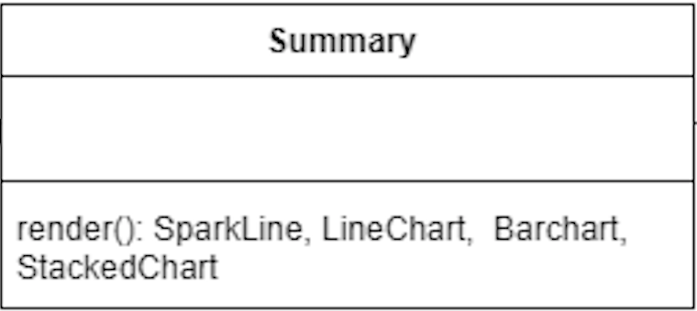

Figure : Summary class

**Method Detail:**

|  |  |
| --- | --- |
| **ID** | 1 |
| **Name** | render () |
| **Parameters** | - |
| **Description** | It is used to render sparkline, line chart, bar chart and stacked chart. |
| **Returns** | SparkLine, LineChart, Barchart, StackedChart |

## CD-12 SparkLine

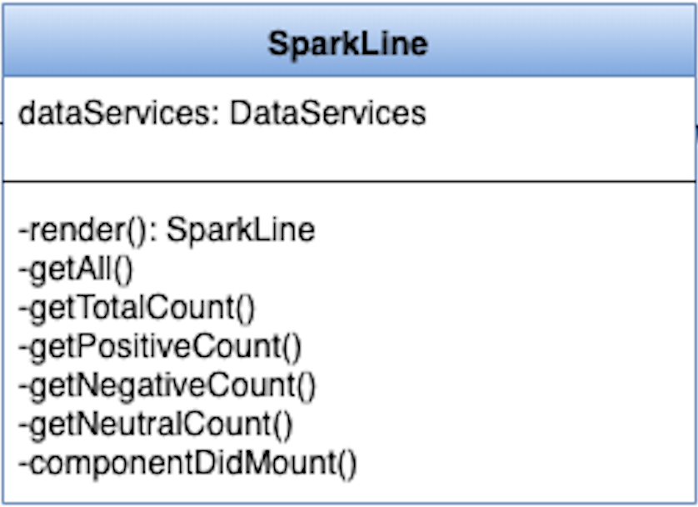

Figure : SparkLine class

**Field Summary**

|  |  |  |  |  |
| --- | --- | --- | --- | --- |
| ID | Modifier | Type | Field | Description |
| 1 | Default | dataServices | DataServices | It is an instance of DataService |

**Method Detail:**

|  |  |
| --- | --- |
| **ID** | 1 |
| **Name** | render () |
| **Parameters** | - |
| **Description** | It is used to render component |
| **Returns** | <SparkLine> |

|  |  |
| --- | --- |
| **ID** | 2 |
| **Name** | getAll () |
| **Parameters** | - |
| **Description** | This method is used to get all data. |
| **Returns** | <Word-Cloud> |

|  |  |
| --- | --- |
| **ID** | 3 |
| **Name** | getTotalCount () |
| **Parameters** | - |
| **Description** | It is used to get total count |
| **Returns** | <Word-Cloud> |

|  |  |
| --- | --- |
| **ID** | 4 |
| **Name** | getPositiveCount () |
| **Parameters** | - |
| **Description** | It is used to get positive count |
| **Returns** | - |

|  |  |
| --- | --- |
| **ID** | 5 |
| **Name** | getNegativeCount () |
| **Parameters** | - |
| **Description** | It is used to get negative count |
| **Returns** | - |

|  |  |
| --- | --- |
| **ID** | 6 |
| **Name** | getNeutralCount () |
| **Parameters** | - |
| **Description** | It is used to get neutral count |
| **Returns** | - |

|  |  |
| --- | --- |
| **ID** | 7 |
| **Name** | componentDidMount () |
| **Parameters** | - |
| **Description** | It is used to load data from local storage after all components are rendered. |
| **Returns** | - |

## CD-13 LineChart

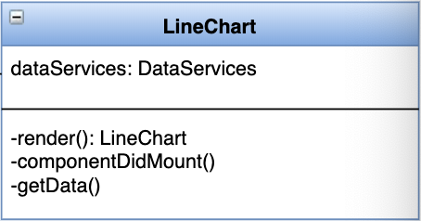

Figure : LineChart class

**Field Summary**

|  |  |  |  |  |
| --- | --- | --- | --- | --- |
| ID | Modifier | Type | Field | Description |
| 1 | Default | DataServices | dataServices | It is an instance of DataService |

**Method Detail:**

|  |  |
| --- | --- |
| **ID** | 1 |
| **Name** | render () |
| **Parameters** | - |
| **Description** | It is used to render component. |
| **Returns** | LineChart |

|  |  |
| --- | --- |
| **ID** | 2 |
| **Name** | componentDidMount () |
| **Parameters** |  |
| **Description** | It is used to load data from local storage after all components are rendered. |
| **Returns** | - |

|  |  |
| --- | --- |
| **ID** | 3 |
| **Name** | getData () |
| **Parameters** |  |
| **Description** | It is used to get data for using to line chart. |
| **Returns** | - |

## CD-14 BarChart

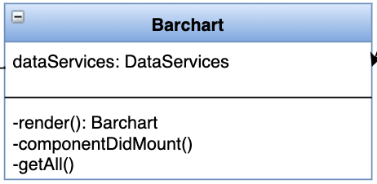



Figure : BarChart class

**Field Summary**

|  |  |  |  |  |
| --- | --- | --- | --- | --- |
| ID | Modifier | Type | Field | Description |
| 1 | Default | DataServices | dataServices | It is an instance of DataService |

**Method Detail:**

|  |  |
| --- | --- |
| **ID** | 1 |
| **Name** | render () |
| **Parameters** | - |
| **Description** | It is used to render component. |
| **Returns** | Barchart |

|  |  |
| --- | --- |
| **ID** | 2 |
| **Name** | componentDidMount () |
| **Parameters** | - |
| **Description** | It is used to load data from local storage after all components are rendered. |
| **Returns** | - |

|  |  |
| --- | --- |
| **ID** | 3 |
| **Name** | getAll () |
| **Parameters** | - |
| **Description** | It is used to get all data for using to bar chart. |
| **Returns** | - |

## CD-15 StackedChart

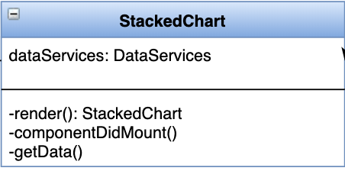



Figure : StackedChart class

**Field Summary**

|  |  |  |  |  |
| --- | --- | --- | --- | --- |
| ID | Modifier | Type | Field | Description |
| 1 | Default | DataServices | dataServices | It is an instance of DataService |

**Method Detail:**

|  |  |
| --- | --- |
| **ID** | 1 |
| **Name** | render () |
| **Parameters** | - |
| **Description** | It is used to render component |
| **Returns** | StackedChart |

|  |  |
| --- | --- |
| **ID** | 2 |
| **Name** | componentDidMount () |
| **Parameters** |  |
| **Description** | It is used to load data from local storage after all components are rendered. |
| **Returns** |  |

|  |  |
| --- | --- |
| **ID** | 3 |
| **Name** | getData () |
| **Parameters** |  |
| **Description** | It is used to get data for using to stacked chart. |
| **Returns** |  |

## CD-16 DataService

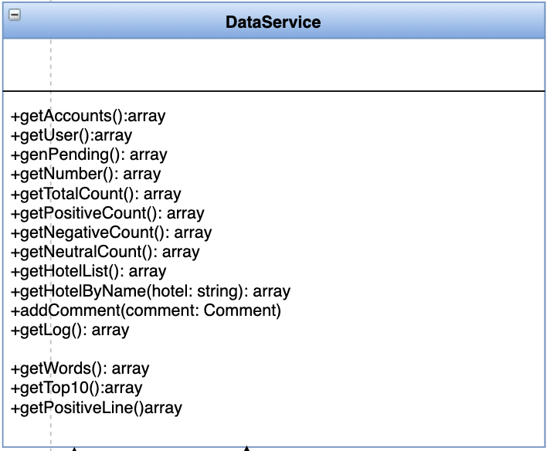

Figure : DataService class

**Method Detail:**

|  |  |
| --- | --- |
| **ID** | 1 |
| **Name** | getAccounts () |
| **Parameters** | - |
| **Description** | It is used to get accounts |
| **Returns** | array |

|  |  |
| --- | --- |
| **ID** | 2 |
| **Name** | getUser () |
| **Parameters** | - |
| **Description** | It is used to get users |
| **Returns** | array |

|  |  |
| --- | --- |
| **ID** | 3 |
| **Name** | getPending () |
| **Parameters** | - |
| **Description** | It is used to get pending |
| **Returns** | array |

|  |  |
| --- | --- |
| **ID** | 4 |
| **Name** | getNumber () |
| **Parameters** | - |
| **Description** | It is used to get number |
| **Returns** | array |

|  |  |
| --- | --- |
| **ID** | 5 |
| **Name** | getTotalCount () |
| **Parameters** | - |
| **Description** | It is used to get total count |
| **Returns** | array |

|  |  |
| --- | --- |
| **ID** | 6 |
| **Name** | getPositiveCount () |
| **Parameters** | - |
| **Description** | It is used to get positive count |
| **Returns** | array |

|  |  |
| --- | --- |
| **ID** | 7 |
| **Name** | getNegativeCount () |
| **Parameters** | - |
| **Description** | It is used to get negative count |
| **Returns** | array |

|  |  |
| --- | --- |
| **ID** | 8 |
| **Name** | getNeutralCount () |
| **Parameters** | - |
| **Description** | It is used to get neutral count |
| **Returns** | array |

|  |  |
| --- | --- |
| **ID** | 9 |
| **Name** | getHotelList () |
| **Parameters** | - |
| **Description** | It is used to get hotel list |
| **Returns** | array |

|  |  |
| --- | --- |
| **ID** | 10 |
| **Name** | getHotelByName () |
| **Parameters** | string: hotel |
| **Description** | It is used to get hotel by name |
| **Returns** | array |

|  |  |
| --- | --- |
| **ID** | 11 |
| **Name** | addComment () |
| **Parameters** | comment: Comment |
| **Description** | It is used to add comments |
| **Returns** | - |

|  |  |
| --- | --- |
| **ID** | 12 |
| **Name** | getLog () |
| **Parameters** | - |
| **Description** | It is used to get log information |
| **Returns** | array |

|  |  |
| --- | --- |
| **ID** | 13 |
| **Name** | getWords () |
| **Parameters** | - |
| **Description** | It is used to get the frequency of each word in comments from database. |
| **Returns** | array |

|  |  |
| --- | --- |
| **ID** | 14 |
| **Name** | getTop10 () |
| **Parameters** | - |
| **Description** | It is used to get the comments details of top 10 hotels with the most comments. |
| **Returns** | array |

|  |  |
| --- | --- |
| **ID** | 15 |
| **Name** | getPositiveLine () |
| **Parameters** | - |
| **Description** | It is used to get the positive comments of each year. |
| **Returns** | array |

## CD-17 UserService

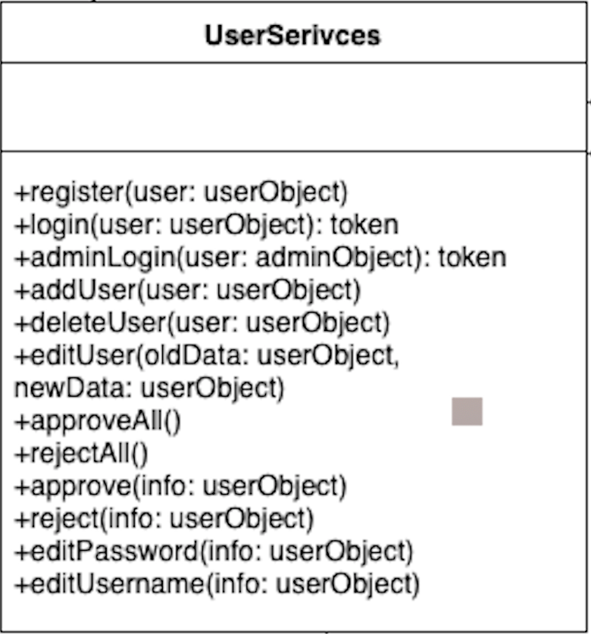



Figure : UserService class

**Method Detail:**

|  |  |
| --- | --- |
| **ID** | 1 |
| **Name** | register () |
| **Parameters** | user: userObject |
| **Description** | It is used to register account. |
| **Returns** | - |

|  |  |
| --- | --- |
| **ID** | 2 |
| **Name** | login () |
| **Parameters** | user: userObject |
| **Description** | It is used to login to the system |
| **Returns** | token |

|  |  |
| --- | --- |
| **ID** | 3 |
| **Name** | adminLogin () |
| **Parameters** | user: adminObject |
| **Description** | It is used to admin log in to the system. |
| **Returns** | token |

|  |  |
| --- | --- |
| **ID** | 4 |
| **Name** | addUser () |
| **Parameters** | user: userObject |
| **Description** | It is used to add user. |
| **Returns** | - |

|  |  |
| --- | --- |
| **ID** | 5 |
| **Name** | deleteUser () |
| **Parameters** | user: userObject |
| **Description** | It is used to delete user. |
| **Returns** | - |

|  |  |
| --- | --- |
| **ID** | 6 |
| **Name** | editUser () |
| **Parameters** | oldData: userObject, newData: userObject |
| **Description** | It is used to edit user information. |
| **Returns** | - |

|  |  |
| --- | --- |
| **ID** | 7 |
| **Name** | newData () |
| **Parameters** | : userObject |
| **Description** | It is used to get new data. |
| **Returns** | - |

|  |  |
| --- | --- |
| **ID** | 8 |
| **Name** | approveAll () |
| **Parameters** | - |
| **Description** | It is used to approve all admin register requests |
| **Returns** | - |

|  |  |
| --- | --- |
| **ID** | 9 |
| **Name** | rejectAll () |
| **Parameters** | - |
| **Description** | It is used to reject all admin register requests |
| **Returns** | array |

|  |  |
| --- | --- |
| **ID** | 10 |
| **Name** | approve () |
| **Parameters** | info: userObject |
| **Description** | It is used to approval admin register requests |
| **Returns** | - |

|  |  |
| --- | --- |
| **ID** | 11 |
| **Name** | reject () |
| **Parameters** | info: userObject |
| **Description** | It is used to reject admin register requests |
| **Returns** | - |

|  |  |
| --- | --- |
| **ID** | 12 |
| **Name** | edit Password () |
| **Parameters** | info: userObject |
| **Description** | It is used to edit password |
| **Returns** | - |

|  |  |
| --- | --- |
| **ID** | 13 |
| **Name** | editUsername () |
| **Parameters** | info: userObject |
| **Description** | It is used to edit username information |
| **Returns** | - |

## CD-18 Mongo

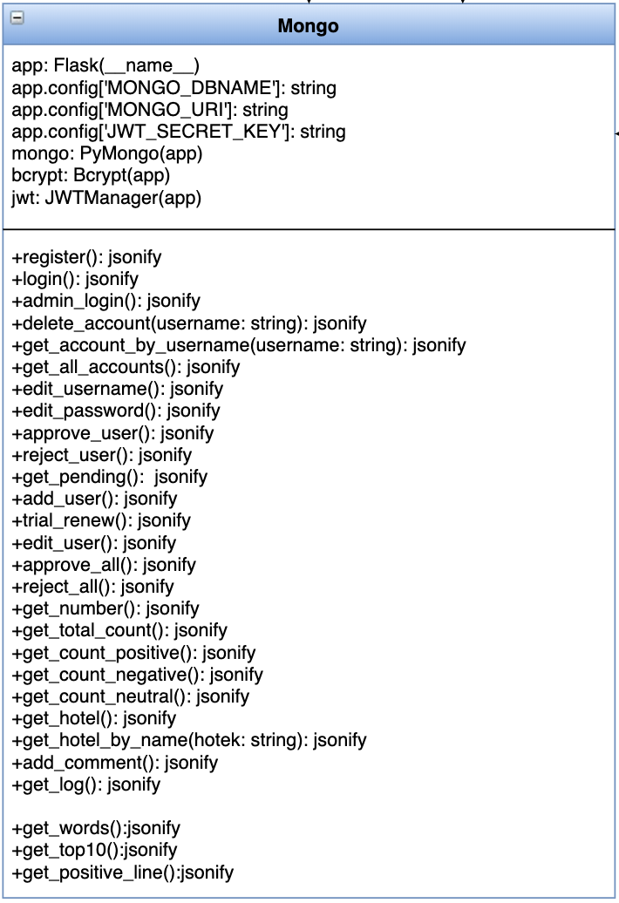

Figure : Mongo class

**Field Summary**

|  |  |  |  |  |
| --- | --- | --- | --- | --- |
| ID | Modifier | Type | Field | Description |
| 1 | Default | Flask(_name_) | app | Create Flask application |
| 2 | Default | string | app.config[‘MONGO_DBNAME’] | Config the MongoDB name |
| 3 | Default | string | app. config[‘MONGO_URL’] string | Config the MongoDB URL name |
| 4 | Default | string | app.config[‘JWT_SECRET_KEY’] | Config JWT_SECRET_KEY |
| 5 | Default | PyMongo(app) | mongo | Create PyMongo application by using app |
| 6 | Default | Bcrypt(app) | bcrypt | Create Bcrypt object by using app |
| 7 | Default | JWTManager(app) | jwt | Create JWTManager object by using app |

**Method Detail:**

|  |  |
| --- | --- |
| **ID** | 1 |
| **Name** | register () |
| **Parameters** | - |
| **Description** | It is used to register account. |
| **Returns** | jsonify |

|  |  |
| --- | --- |
| **ID** | 2 |
| **Name** | login () |
| **Parameters** | - |
| **Description** | It is used to login to system. |
| **Returns** | jsonify |

|  |  |
| --- | --- |
| **ID** | 3 |
| **Name** | admin_login () |
| **Parameters** | - |
| **Description** | It is used for admin to login to system. |
| **Returns** | jsonify |

|  |  |
| --- | --- |
| **ID** | 4 |
| **Name** | delete_account () |
| **Parameters** | username: string |
| **Description** | It is used to delete account. |
| **Returns** | jsonify |

|  |  |
| --- | --- |
| **ID** | 5 |
| **Name** | get_account_by_username () |
| **Parameters** | username: string |
| **Description** | It is used to get account by username |
| **Returns** | jsonify |

|  |  |
| --- | --- |
| **ID** | 6 |
| **Name** | get_all_accounts () |
| **Parameters** | - |
| **Description** | It is used to get all users |
| **Returns** | jsonify |

|  |  |
| --- | --- |
| **ID** | 7 |
| **Name** | edit_username () |
| **Parameters** | - |
| **Description** | It is used to edit username |
| **Returns** | jsonify |

|  |  |
| --- | --- |
| **ID** | 8 |
| **Name** | edit_password () |
| **Parameters** | - |
| **Description** | It is used to edit password |
| **Returns** | jsonify |

|  |  |
| --- | --- |
| **ID** | 9 |
| **Name** | approve_user () |
| **Parameters** | - |
| **Description** | It is used to approve user account register request |
| **Returns** | jsonify |

|  |  |
| --- | --- |
| **ID** | 10 |
| **Name** | reject_user () |
| **Parameters** | - |
| **Description** | It is used to reject user account register request |
| **Returns** | jsonify |

|  |  |
| --- | --- |
| **ID** | 11 |
| **Name** | get_pending () |
| **Parameters** | - |
| **Description** | It is used to get pending |
| **Returns** | jsonify |

|  |  |
| --- | --- |
| **ID** | 12 |
| **Name** | add_user () |
| **Parameters** | - |
| **Description** | It is used to add new user |
| **Returns** | jsonify |

|  |  |
| --- | --- |
| **ID** | 13 |
| **Name** | trial_renew () |
| **Parameters** | - |
| **Description** | It is used to renew user trial time. |
| **Returns** | jsonify |

|  |  |
| --- | --- |
| **ID** | 14 |
| **Name** | edit_user () |
| **Parameters** | - |
| **Description** | It is used to edit user. |
| **Returns** | jsonify |

|  |  |
| --- | --- |
| **ID** | 15 |
| **Name** | approve_all () |
| **Parameters** | - |
| **Description** | It is used to approve all request in waiting list. |
| **Returns** | jsonify |

|  |  |
| --- | --- |
| **ID** | 16 |
| **Name** | reject_all () |
| **Parameters** | - |
| **Description** | It is used to reject all request in waiting list. |
| **Returns** | jsonify |

|  |  |
| --- | --- |
| **ID** | 17 |
| **Name** | get_number () |
| **Parameters** | - |
| **Description** | It is used to get number. |
| **Returns** | jsonify |

|  |  |
| --- | --- |
| **ID** | 18 |
| **Name** | get_total_count () |
| **Parameters** | - |
| **Description** | It is used to get total counts |
| **Returns** | jsonify |

|  |  |
| --- | --- |
| **ID** | 19 |
| **Name** | get_count_positive () |
| **Parameters** | - |
| **Description** | This method will receive http GET request and get the positive comment count by date from database. |
| **Returns** | jsonify |

|  |  |
| --- | --- |
| **ID** | 20 |
| **Name** | get_count_negative () |
| **Parameters** | - |
| **Description** | This method will receive http GET request and get the negative comment count by date from database. |
| **Returns** | jsonify |

|  |  |
| --- | --- |
| **ID** | 21 |
| **Name** | get_count_neutral () |
| **Parameters** | - |
| **Description** | This method will receive http GET request and get the neutral comment count by date from database. |
| **Returns** | jsonify |

|  |  |
| --- | --- |
| **ID** | 22 |
| **Name** | get_hotel () |
| **Parameters** | - |
| **Description** | This method will receive http GET request and get the number of comments of each hotel from database. |
| **Returns** | jsonify |

|  |  |
| --- | --- |
| **ID** | 23 |
| **Name** | get_hotel_by_name () |
| **Parameters** | string: hotel |
| **Description** | This method will receive http GET request and get the comment of inputting hotel from database. |
| **Returns** | jsonify |

|  |  |
| --- | --- |
| **ID** | 24 |
| **Name** | add_comment () |
| **Parameters** |  |
| **Description** | This method will receive http POST request and store the comment to database. |
| **Returns** | jsonify |

|  |  |
| --- | --- |
| **ID** | 25 |
| **Name** | get_log () |
| **Parameters** |  |
| **Description** | It is used to get log information. |
| **Returns** | jsonify |

|  |  |
| --- | --- |
| **ID** | 26 |
| **Name** | get_words () |
| **Parameters** |  |
| **Description** | It is used to get words from database. |
| **Returns** | jsonify |

|  |  |
| --- | --- |
| **ID** | 27 |
| **Name** | get_top10 () |
| **Parameters** |  |
| **Description** | It is used to get top 10 hotels from database. |
| **Returns** | jsonify |

|  |  |
| --- | --- |
| **ID** | 27 |
| **Name** | get_positive_line () |
| **Parameters** |  |
| **Description** | It is used to get the positive comments of each year from database. |
| **Returns** | jsonify |

## CD-19 DataProvider

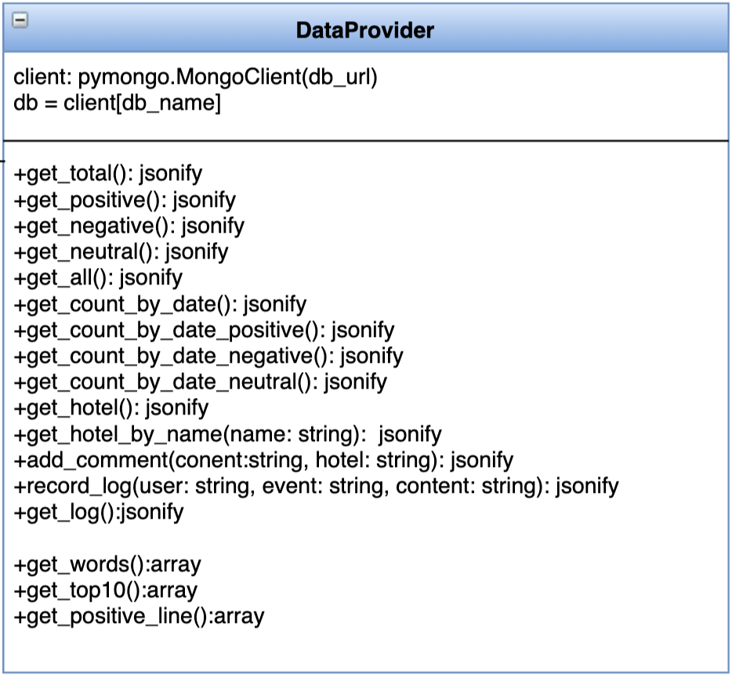

Figure : DataProvider class

**Field Summary**

|  |  |  |  |  |
| --- | --- | --- | --- | --- |
| ID | Modifier | Type | Field | Description |
| 1 | Default | pymongo | client | It is an instance of pymongo |
| 2 | Default | client | db | It is an instance of pymongo client. |

**Method Detail:**

|  |  |
| --- | --- |
| **ID** | 1 |
| **Name** | get_total () |
| **Parameters** | - |
| **Description** | This method will get counts of comments from database. |
| **Returns** | jsonify |

|  |  |
| --- | --- |
| **ID** | 2 |
| **Name** | get_positive () |
| **Parameters** | - |
| **Description** | This method will get positive comment data from database. |
| **Returns** | jsonify |

|  |  |
| --- | --- |
| **ID** | 3 |
| **Name** | get_negative () |
| **Parameters** | - |
| **Description** | This method will get negative comment data from database. |
| **Returns** | jsonify |

|  |  |
| --- | --- |
| **ID** | 4 |
| **Name** | get_neutral () |
| **Parameters** | - |
| **Description** | This method will get neutral comment data from database. |
| **Returns** | jsonify |

|  |  |
| --- | --- |
| **ID** | 5 |
| **Name** | get_all () |
| **Parameters** | - |
| **Description** | This method will get comment data from database. |
| **Returns** | jsonify |

|  |  |
| --- | --- |
| **ID** | 6 |
| **Name** | get_count_by_date () |
| **Parameters** | - |
| **Description** | This method will get the comment count by date from database. |
| **Returns** | jsonify |

|  |  |
| --- | --- |
| **ID** | 7 |
| **Name** | get_count_by_date_positive () |
| **Parameters** | - |
| **Description** | This method will get the positive comment count by date from database. |
| **Returns** | jsonify |

|  |  |
| --- | --- |
| **ID** | 8 |
| **Name** | get_count_by_date_negative () |
| **Parameters** | - |
| **Description** | This method will get the negative comment count by date from database. |
| **Returns** | jsonify |

|  |  |
| --- | --- |
| **ID** | 9 |
| **Name** | get_count_by_date_neutral () |
| **Parameters** | - |
| **Description** | This method will get the neutral comment count by date from database. |
| **Returns** | jsonify |

|  |  |
| --- | --- |
| **ID** | 10 |
| **Name** | get_hotel () |
| **Parameters** | - |
| **Description** | This method will get the number of comments of each hotel from database. |
| **Returns** | jsonify |

|  |  |
| --- | --- |
| **ID** | 11 |
| **Name** | get_hotel_by_name () |
| **Parameters** | string: name |
| **Description** | This method will get the comment of inputting hotel from database. |
| **Returns** | jsonify |

|  |  |
| --- | --- |
| **ID** | 12 |
| **Name** | add_comment () |
| **Parameters** | string: content, string: hotel |
| **Description** | This method will store the comment to database. |
| **Returns** | jsonify |

|  |  |
| --- | --- |
| **ID** | 13 |
| **Name** | record_log () |
| **Parameters** | string: user, string: event, string: content |
| **Description** | This method will record log information and store to database. |
| **Returns** | jsonify |

|  |  |
| --- | --- |
| **ID** | 14 |
| **Name** | get_log () |
| **Parameters** | - |
| **Description** | This method will get the log information. |
| **Returns** | jsonify |

|  |  |
| --- | --- |
| **ID** | 15 |
| **Name** | get_words () |
| **Parameters** | - |
| **Description** | It is used to get words to word cloud. |
| **Returns** | array |

|  |  |
| --- | --- |
| **ID** | 16 |
| **Name** | get_top10 () |
| **Parameters** | - |
| **Description** | It is used to get top 10 hotels comments |
| **Returns** | array |

|  |  |
| --- | --- |
| **ID** | 17 |
| **Name** | get_positive_line () |
| **Parameters** | - |
| **Description** | It is used to get the positive comments of each year. |
| **Returns** | array |

## CD-20 Log

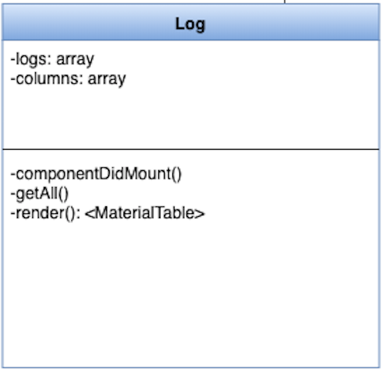

Figure : Log class

**Field Summary**

|  |  |  |  |  |
| --- | --- | --- | --- | --- |
| ID | Modifier | Type | Field | Description |
| 1 | Default | logs | array | It is an array of log information |
| 2 | Default | columns | array | It is an array of columns. |

**Method Detail:**

|  |  |
| --- | --- |
| **ID** | 1 |
| **Name** | componentDidMount () |
| **Parameters** | - |
| **Description** | It is used to get data from backend before rending |
| **Returns** | - |

|  |  |
| --- | --- |
| **ID** | 2 |
| **Name** | getAll () |
| **Parameters** | - |
| **Description** | This method is used to get all hotels. |
| **Returns** | - |

|  |  |
| --- | --- |
| **ID** | 3 |
| **Name** | render () |
| **Parameters** | - |
| **Description** | It is used to render component |
| **Returns** | <MaterialTable> |

## CD-21 Hotel

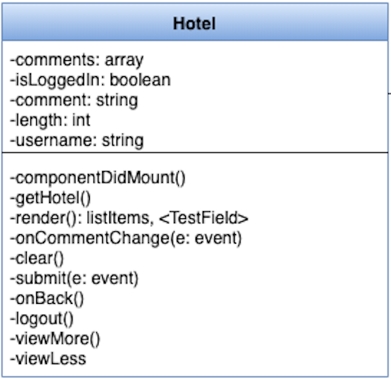

Figure : Hotel class

**Field Summary**

|  |  |  |  |  |
| --- | --- | --- | --- | --- |
| ID | Modifier | Type | Field | Description |
| 1 | Default | comments | array | It is an array of comments. |
| 2 | Default | isLoggedln | boolean | It is used to judge if logged in |
| 3 | Default | comment | string | It is a string of comment. |
| 4 | Default | length | int | It is an integer of the length of displayed comment. |
| 5 | Default | username | string | It is account username |

**Method Detail:**

|  |  |
| --- | --- |
| **ID** | 1 |
| **Name** | componentDidMount () |
| **Parameters** | - |
| **Description** | It is used to get data from backend before rending |
| **Returns** | - |

|  |  |
| --- | --- |
| **ID** | 2 |
| **Name** | getHotel () |
| **Parameters** | - |
| **Description** | This method is used to get all hotels. |
| **Returns** | - |

|  |  |
| --- | --- |
| **ID** | 3 |
| **Name** | render () |
| **Parameters** | - |
| **Description** | It is used to render component. |
| **Returns** | listItems, <TestField> |

|  |  |
| --- | --- |
| **ID** | 4 |
| **Name** | onCommentChange () |
| **Parameters** | - |
| **Description** | It is used to view when comment is typing. |
| **Returns** | - |

|  |  |
| --- | --- |
| **ID** | 5 |
| **Name** | clear () |
| **Parameters** | - |
| **Description** | It is used to clear input. |
| **Returns** | - |

|  |  |
| --- | --- |
| **ID** | 6 |
| **Name** | submit () |
| **Parameters** | - |
| **Description** | It is used to submit comment. |
| **Returns** | - |

|  |  |
| --- | --- |
| **ID** | 7 |
| **Name** | onBack () |
| **Parameters** | - |
| **Description** | It is used to listen the back event and return to previous page. |
| **Returns** | - |

|  |  |
| --- | --- |
| **ID** | 8 |
| **Name** | logout () |
| **Parameters** | - |
| **Description** | It is used to log out. |
| **Returns** | - |

|  |  |
| --- | --- |
| **ID** | 9 |
| **Name** | viewMore () |
| **Parameters** | - |
| **Description** | It is used to show more content. |
| **Returns** | - |

|  |  |
| --- | --- |
| **ID** | 10 |
| **Name** | viewLess () |
| **Parameters** | - |
| **Description** | It is used to show less content. |
| **Returns** | - |

## CD-22 View

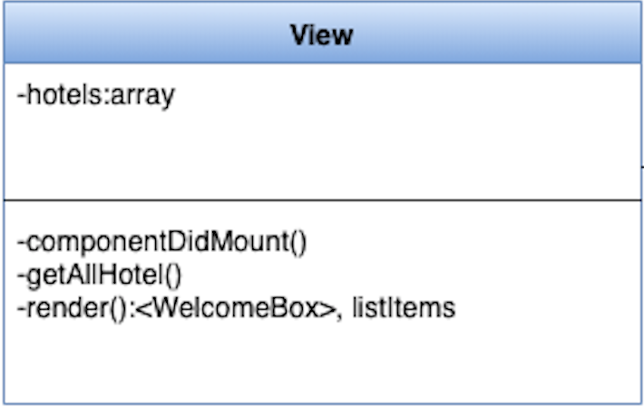

Figure : View class

**Field Summary**

|  |  |  |  |  |
| --- | --- | --- | --- | --- |
| ID | Modifier | Type | Field | Description |
| 1 | Default | hotels | array | It is an array of hotels |

**Method Detail:**

|  |  |
| --- | --- |
| **ID** | 1 |
| **Name** | componentDidMount () |
| **Parameters** | - |
| **Description** | It is used to get data from backend before rending |
| **Returns** | - |

|  |  |
| --- | --- |
| **ID** | 2 |
| **Name** | getAllHotel () |
| **Parameters** | - |
| **Description** | It is used to get all hotels data. |
| **Returns** | - |

|  |  |
| --- | --- |
| **ID** | 3 |
| **Name** | render () |
| **Parameters** | - |
| **Description** | It is used to render component |
| **Returns** | - |

## CD-23 HeatMap

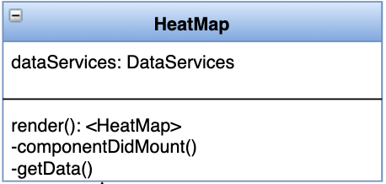

Figure : HeatMap class

**Field Summary**

|  |  |  |  |  |
| --- | --- | --- | --- | --- |
| ID | Modifier | Type | Field | Description |
| 1 | Default | dataServices | DataServices | It is an instance of DataService |

**Method Detail:**

|  |  |
| --- | --- |
| **ID** | 1 |
| **Name** | render () |
| **Parameters** | - |
| **Description** | It is used to render component |
| **Returns** | <HeatMap> |

|  |  |
| --- | --- |
| **ID** | 2 |
| **Name** | componentDidMount () |
| **Parameters** |  |
| **Description** | It is used to load data from local storage after all components are rendered. |
| **Returns** |  |

|  |  |
| --- | --- |
| **ID** | 3 |
| **Name** | getData () |
| **Parameters** | - |
| **Description** | It is used to get data for using to stacked chart. |
| **Returns** |  |

## CD-24 Word-Cloud

Figure : Word-Cloud class

**Field Summary**

|  |  |  |  |  |
| --- | --- | --- | --- | --- |
| ID | Modifier | Type | Field | Description |
| 1 | Default | dataServices | DataServices | It is an instance of DataService |

**Method Detail:**

|  |  |
| --- | --- |
| **ID** | 1 |
| **Name** | render () |
| **Parameters** | - |
| **Description** | It is used to render component |
| **Returns** | <Word-Cloud> |

|  |  |
| --- | --- |
| **ID** | 2 |
| **Name** | componentDidMount () |
| **Parameters** | - |
| **Description** | It is used to load data from local storage after all components are rendered. |
| **Returns** | - |

|  |  |
| --- | --- |
| **ID** | 3 |
| **Name** | getWords () |
| **Parameters** | - |
| **Description** | It is used to get words frequency. |
| **Returns** | - |

## 4.3 ER Diagram

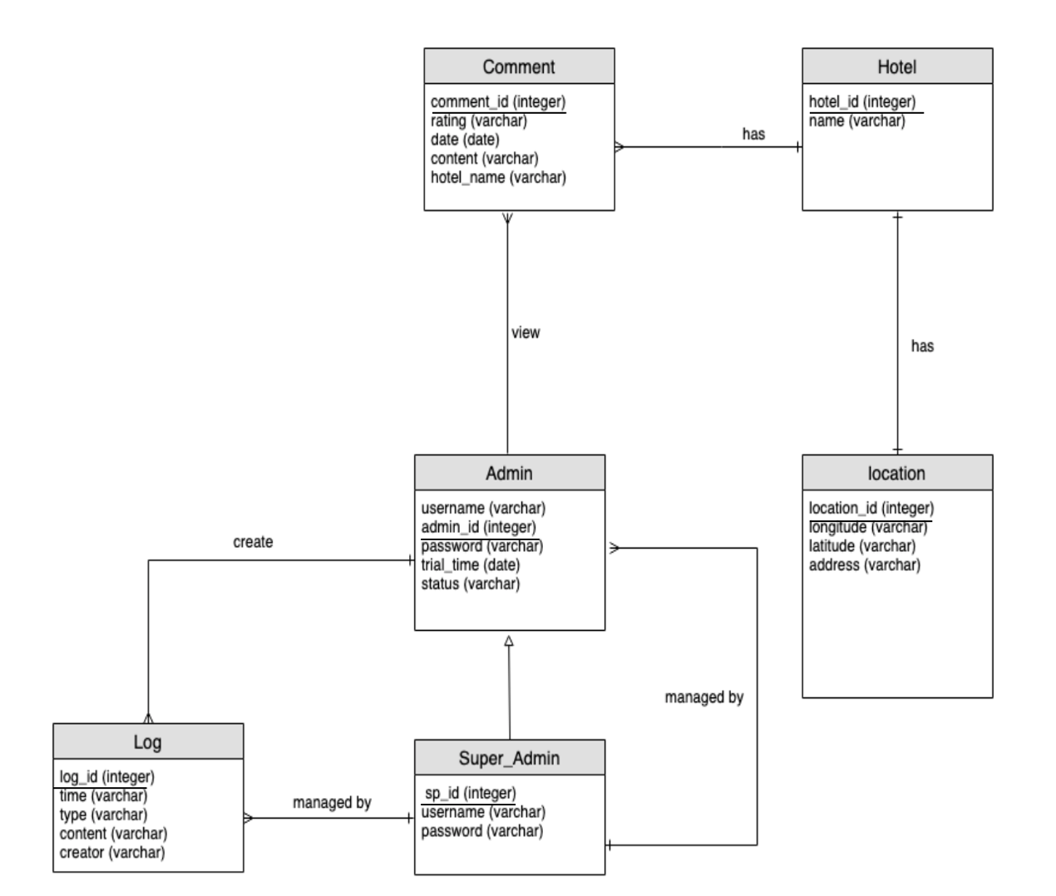

Figure : ER Diagram

## 4.4 Sequence Diagram

(On the next page)

Figure : Sequence Diagram

Sequence diagram including URS-02: Super admin can view account management page, URS-03: Super admin can edit account information, URS-05: Super admin can add admin account directly.

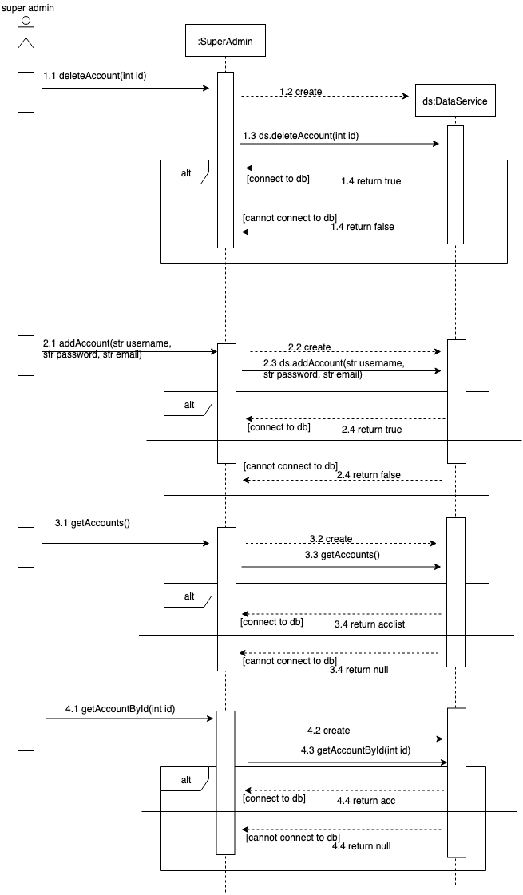

(On the next page)

Figure : Sequence Diagram

This sequence diagram including URS-08: Admin can register account, URS-09: Admin can login to dashboard. URS-10: Admin can edit account information.URS-11: Admin can logout, URS-12: Admin can view all the summary by using sparkline chart, URS-13: Admin can view positive comments rate by using line chart, URS-14: Admin can view word frequency by using bar chart. URS-15: Admin can view number of comments by using bar chart, URS-16: Admin can view types of comments stacked by using column chart.

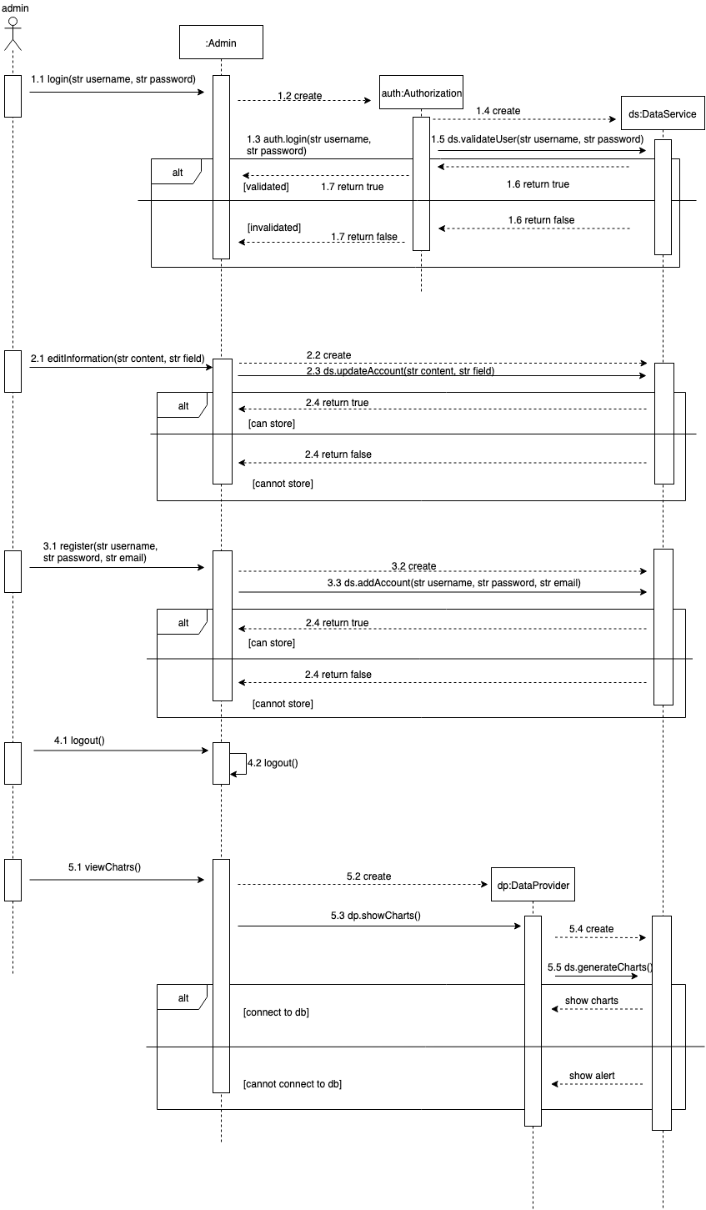chart, URS-18: Admin can view types of comments stacked column chart.

(On the next page)

Figure : Sequence Diagram

This sequence diagram including This sequence diagram including URS-22: All users can view hotel list in the homepage, URS-23: All users can click to view a hotel page, URS-24: All users can view all comments of a hotel, URS-25: Admin can write hotel comments

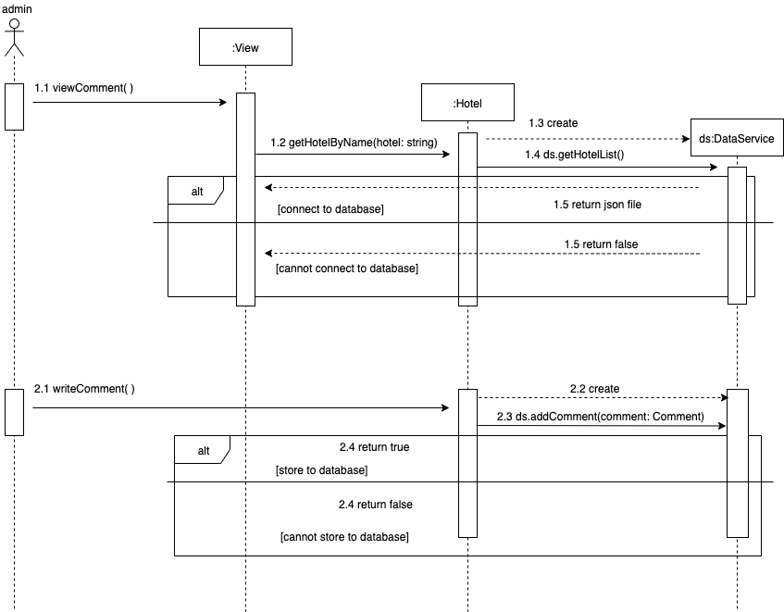

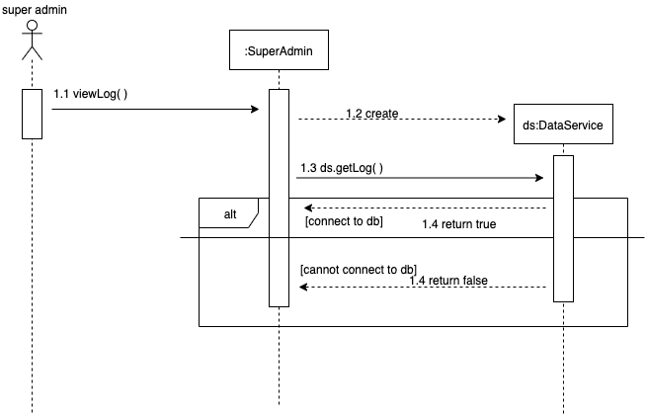

Figure : Sequence Diagram

This sequence diagram including URS-26: Super admin can view the system log (Time, type of log, creator, info)

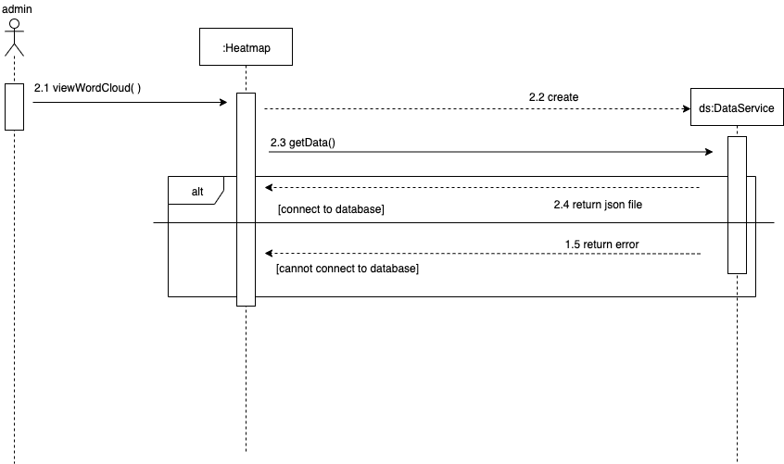

Figure : Sequence Diagram

This sequence diagram including URS-17: Admin can view the most frequently occurring words by word cloud.

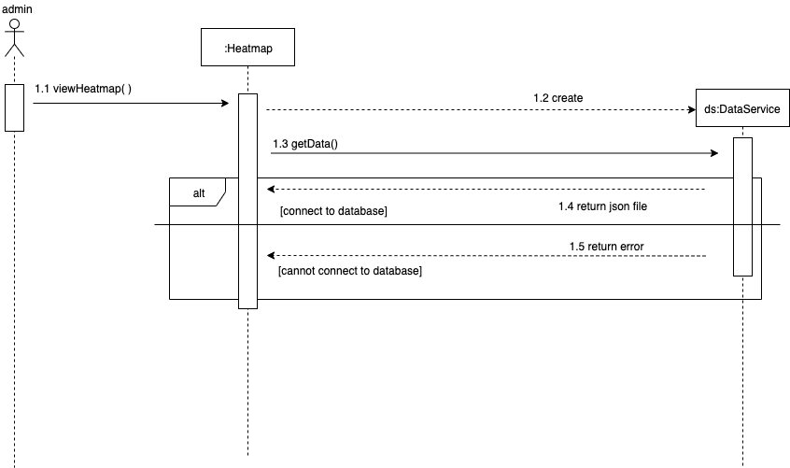

Figure : Sequence Diagram

This sequence diagram including URS-18: Admin can view data presented in a heatmap.

# 5. User Interface Design

## 5.1 Web Application UI

## 5.1.1 W-UI01-Homepage

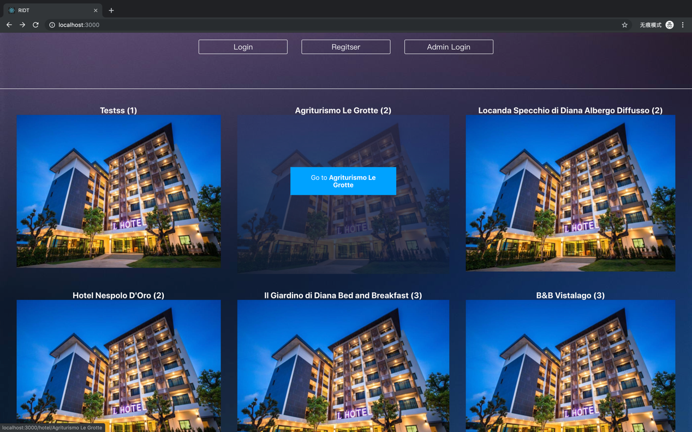

Figure : Homepage UI

This page is using for all users to view system, it consists of:

1. “Login” button for admin to login to dashboard.
2. “Register” button for register new account.
3. “Admin Login” button for super admin login to system.
4. Hotel lists for user to select hotel to know details.

## 5.1.2 W-UI02-Super admin login

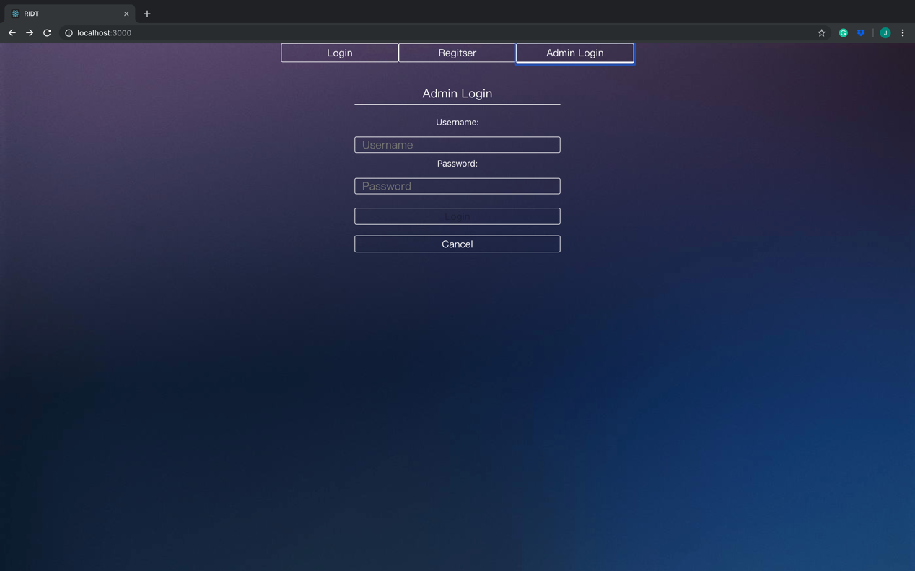

Figure : Super admin login UI

This page is using for Super admin to login to system, it consists of:

1. Text flied used for input username and password.
2. “Login” button for login to dashboard.
3. “Cancel” button for turning to previous page.
4. “Register” button for turning to register page.

5. “Admin Login” button for turning to super admin login page.

## 5.1.3 W-UI03-Register

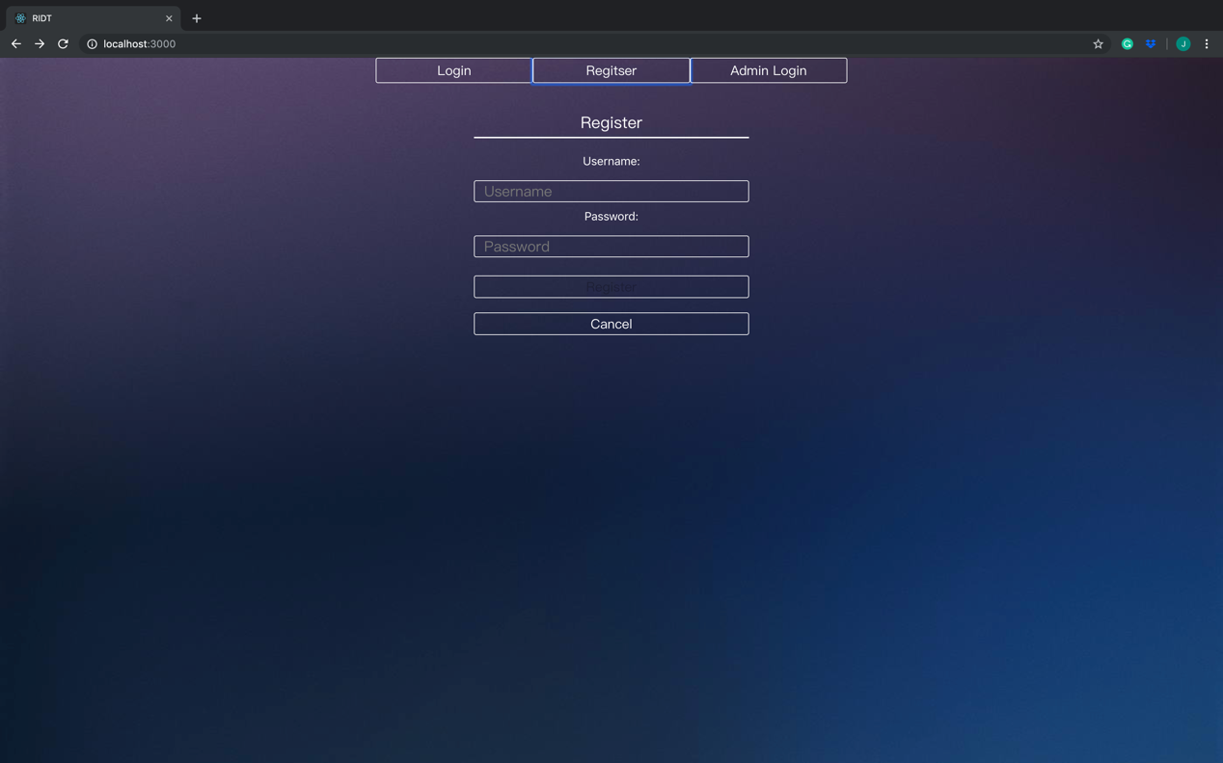

Figure : Register UI

This page is using for admin to register account, they will need to input:

1. Username for creating a new account.
2. Password for login to new account.

It consists of:

1. “Login” column for turning to login page
2. “Admin Login” column for turning to admin login page.
3. “Register” button for submitting register request.
4. “Cancel” button for going to previous page.

## 5.1.4 W-UI04-Admin Login

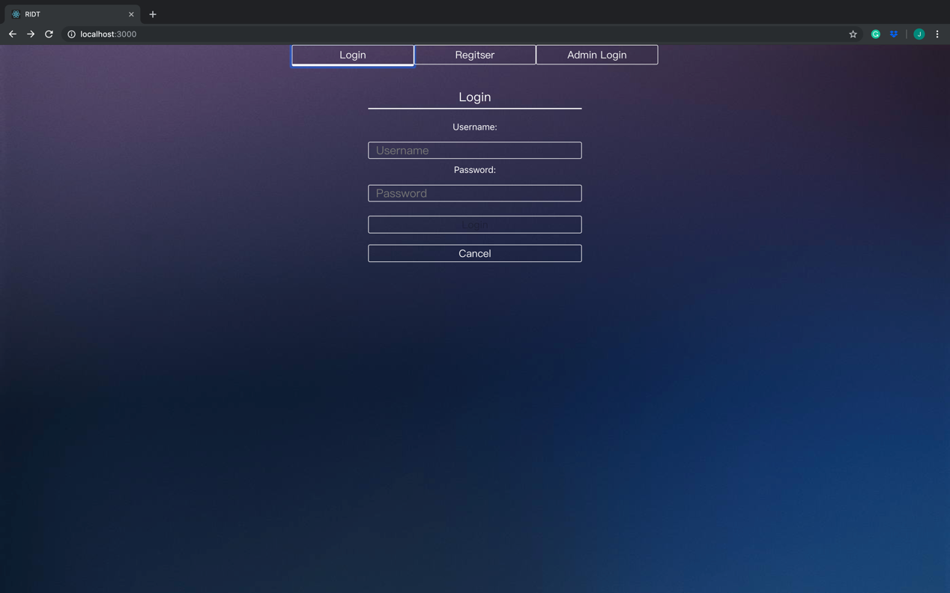

Figure : Admin Login UI

This page is using for admin to login to system, it consists of:

1. Text flied used for input username and password.
2. “Login” button for login to dashboard.
3. “Cancel” button for going to previous page.
4. “Register” button for turning to register page.
5. “Admin Login” button for turning to admin login page.

## 5.1.5 W-UI05-Add accounts

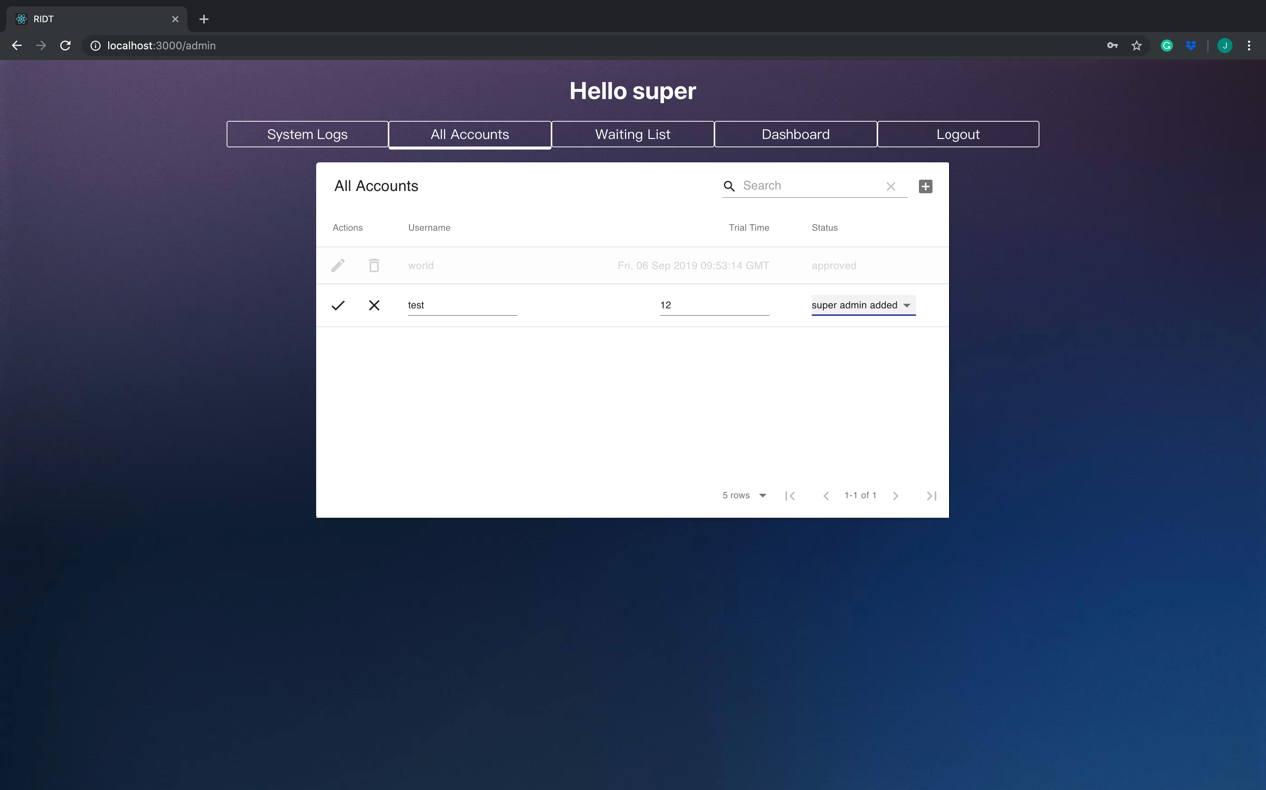

Figure : Add accounts UI

This page is using for super admin to add accounts for admin, it consists of URS-02, URS-03, URS-04, URS-05, URS-06, URS-07, the page consists of:

1. Text flied used for input username and trial time.
2. A search button for searching admin account
3. “Status” button for accepting or rejecting admin register request.
4. “✓” button for saving change.
5. “X” button for canceling change.
6. “System Logs” button for turning to system log page.
7. “Waiting List” button for turning to waiting list page.
8. “Dashboard” button for turning to dashboard.
9. “Logout” button to logout from system.

## 5.1.6 W-UI06-Dashboard

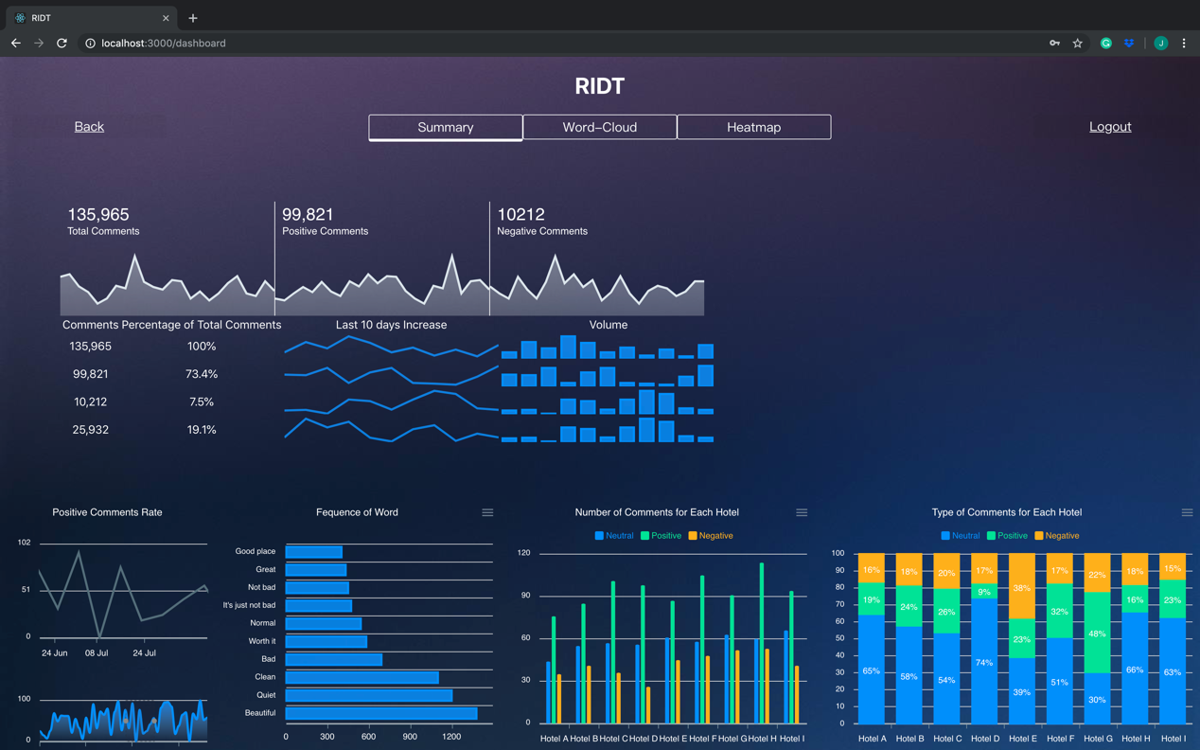

Figure : Dashboard UI

1. “Summary” button for showing all data visualization summaries which have:

1.1 All the summary sparkline chart.

1.2 Positive comments rate line chart.

1.3 Word frequency bar chart.

1.4 Number of comments bar chart.

* 1. Types of comments stacked column chart.

1. “Word-Cloud” column for turning to word cloud page.
2. “Heatmap” button for turning to heatmap page.
3. “Logout” button for decision maker to logout from dashboard.
4. “Back” button for turning to previous page.

## 5.1.7 W-UI07-User profile page

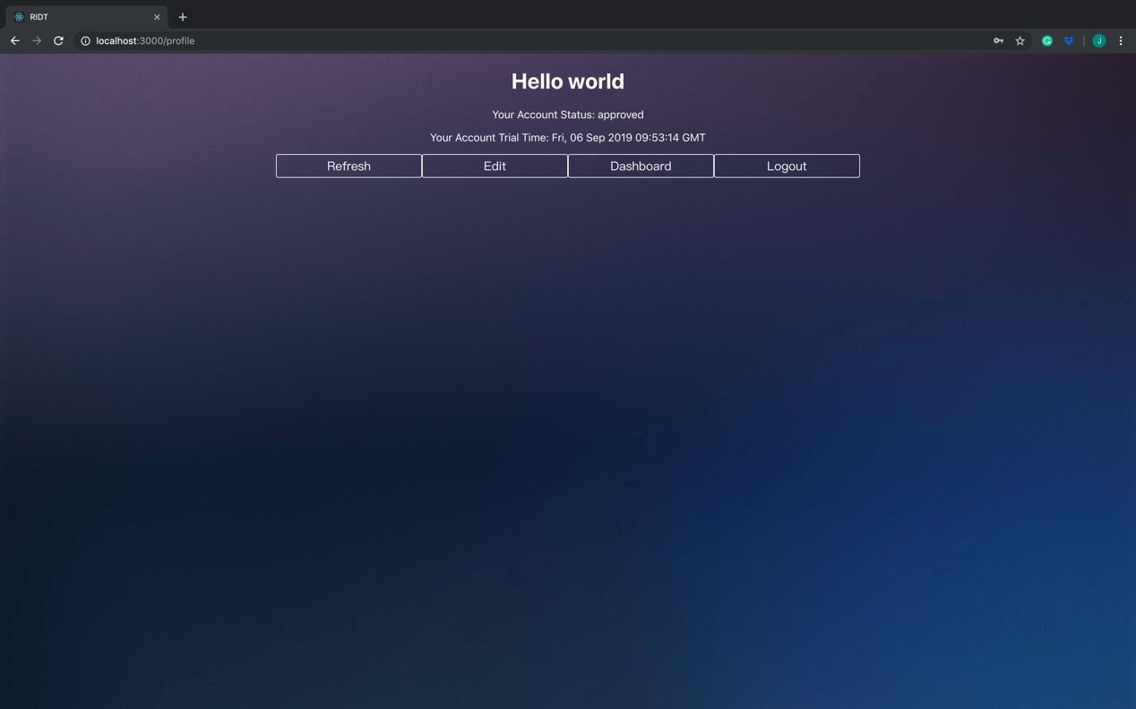

Figure : User profile page UI

This page displays the profile page after admin login, in consists of:

1. “Refresh” button for admin to refresh page.
2. “Edit” button for admin to edit their account information.
3. “Dashboard” button for admin to view the dashboard.
4. “Logout” button for admin to logout from dashboard.

## 5.1.8 W-UI08-Edit username page

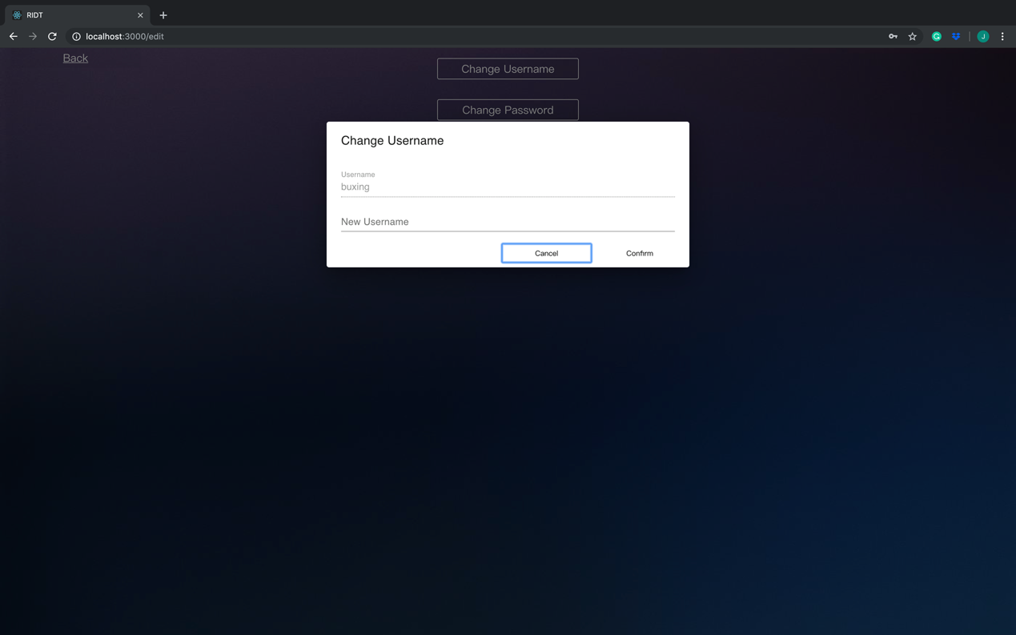

Figure : Edit username page UI

This page displays the edit page after admin login, in consists of:

1. “Cancel” button for admin to cancel.
2. “Confirm” button for admin to confirm changes.
3. “Username” to show the original username.
4. “New username” input box to change the username to what admin want.

## 5.1.9 W-UI09-Edit password page

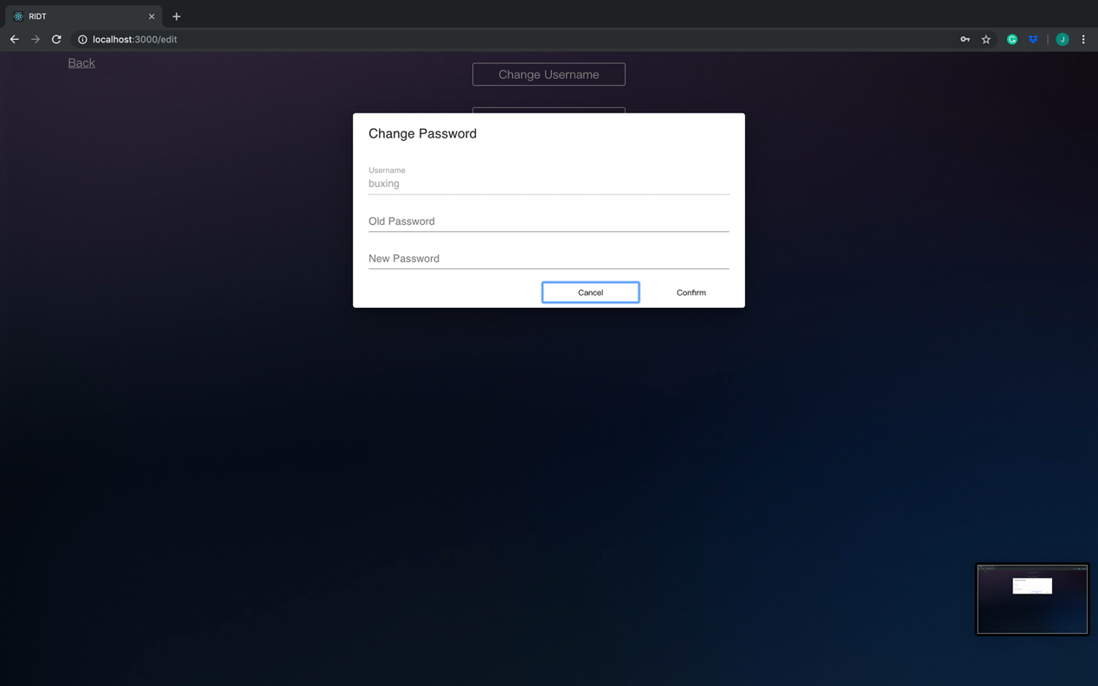

Figure : Edit password page UI

This page displays the edit page after admin login, in consists of:

1. “Cancel” button for admin to cancel.
2. “Confirm” button for admin to confirm changes.
3. “Old password” input box to input the old password.
4. “New password” input box to change the password to what admin want.

## 5.1.10 W-UI10- All users view comments

Figure : All users view comments UI

This page displays the comments, in consists of:

1. “Clear” button to clear the text field.
2. “Submit” button to submit comments.
3. List of comments.
4. “Show more” button for showing more comments.
5. “Show less” button for showing less comments.

## 5.1.11 W-UI11- Admin writes comments

Figure : Admin writes comments UI

This page displays the admin writes comments page, in consists of:

1. “Clear” button to clear the text field.
2. “Submit” button to submit comments.
3. “Back to home” button to return previous page
4. List of comments.
5. “Logout” button to logout system.
6. “Back to home” button for turning to home page.

## 5.1.12 W-UI12- Super admin views system log

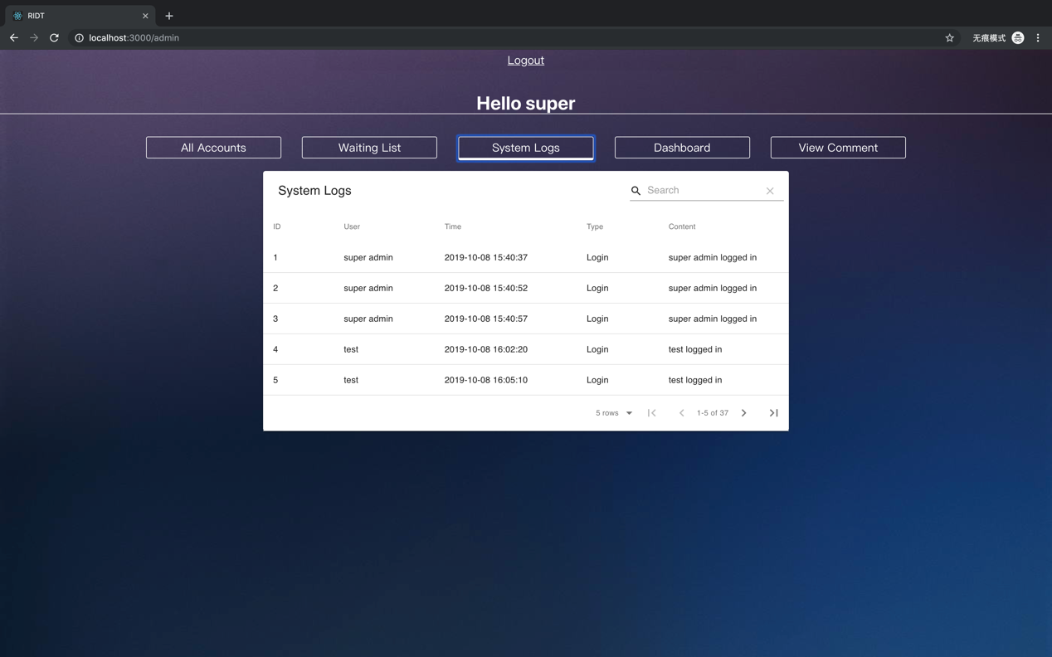

Figure : Super admin views system log UI

This page is using for super admin to view system log, the page consists of:

1. System logs Id
2. System logs User
3. System logs Time
4. System logs Type
5. System logs Content
6. “All accounts” button for turning to all account page
7. “Waiting List” button for turning to waiting list button.
8. “Dashboard” button for turning to dashboard page.
9. “View Comments” button for turning to view comments page.

## 5.1.13 W-UI13- View the word-cloud of data

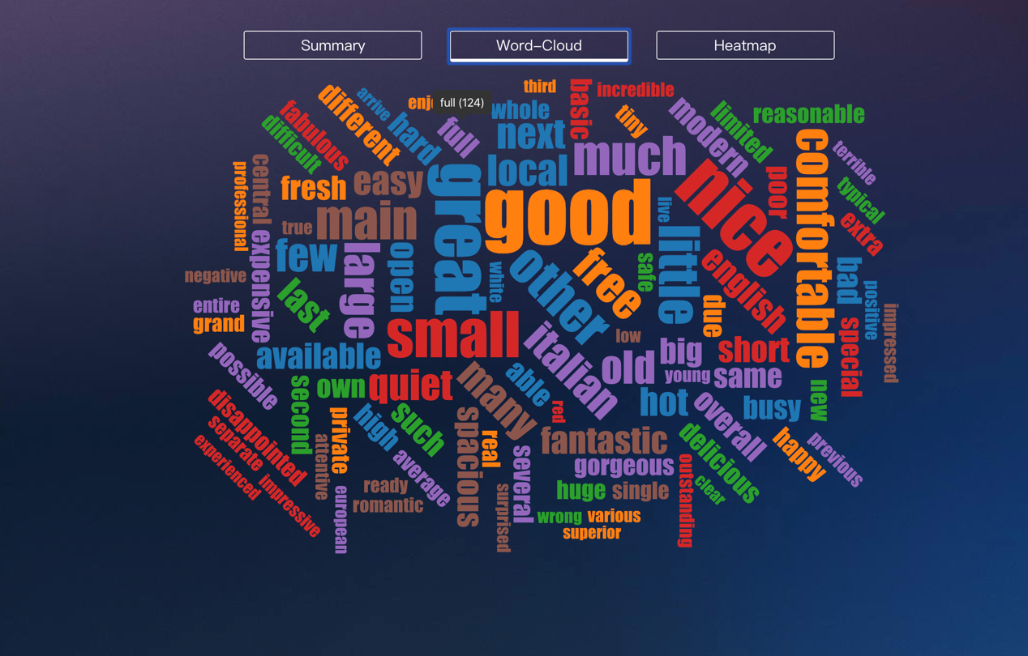

Figure : View the word-cloud of data

This page is using for admin to view word cloud of data, the page consists of:

1. “Summary” button for turning to summary page.
2. “Heatmap” button for turning to heatmap page.
3. Data presented in word-cloud which contains the most frequently occurring words.

## 5.1.14 W-UI14- View the heatmap of data.

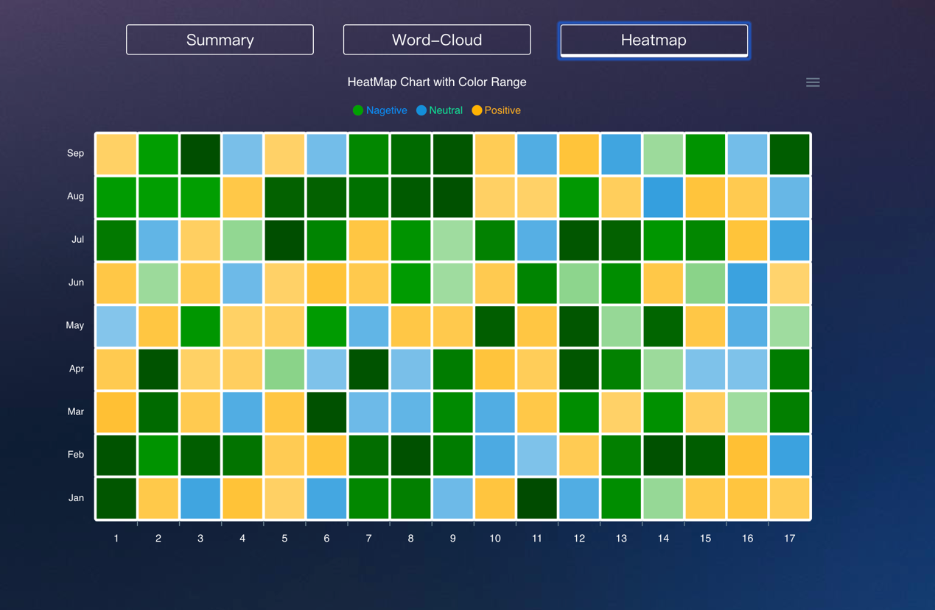

Figure : View the heatmap of data.

This page is using for admin to view heatmap of data, the page consists of:

1. “Summary” button for turning to summary page.
2. “Word-Cloud” button for turning to Wordcloud page.
3. Data presented in a heatmap.
4. “Negative” legend for showing negative comments color range.
5. “Positive” legend for showing positive comments color range.
6. “Neutral” legend for showing neutral comments color range.

## 5.1.15 W-UI15- View the comments by sentiment.

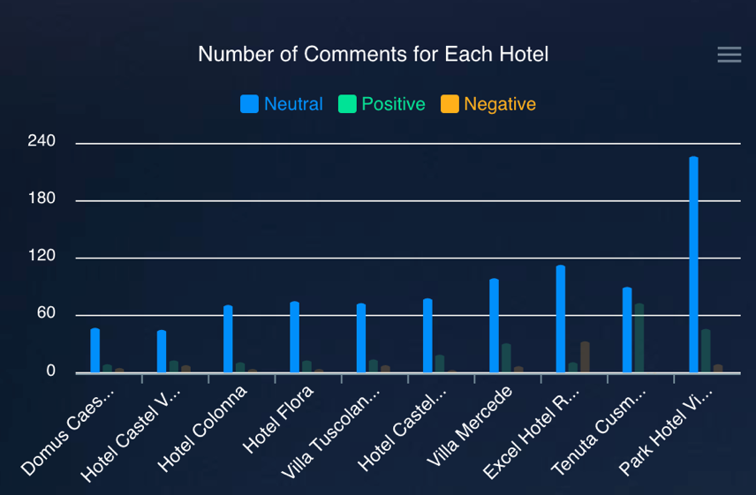

Figure : View the comments by sentiment1

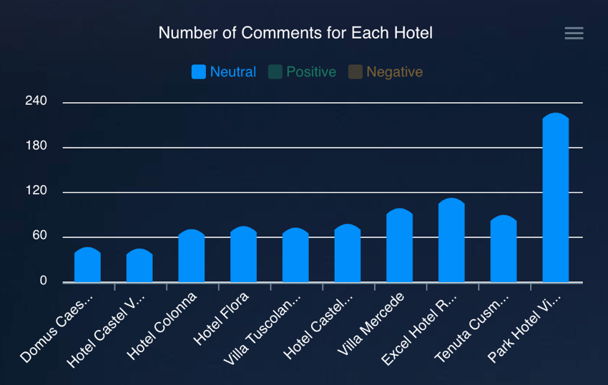

Figure : View the comments by sentiment2

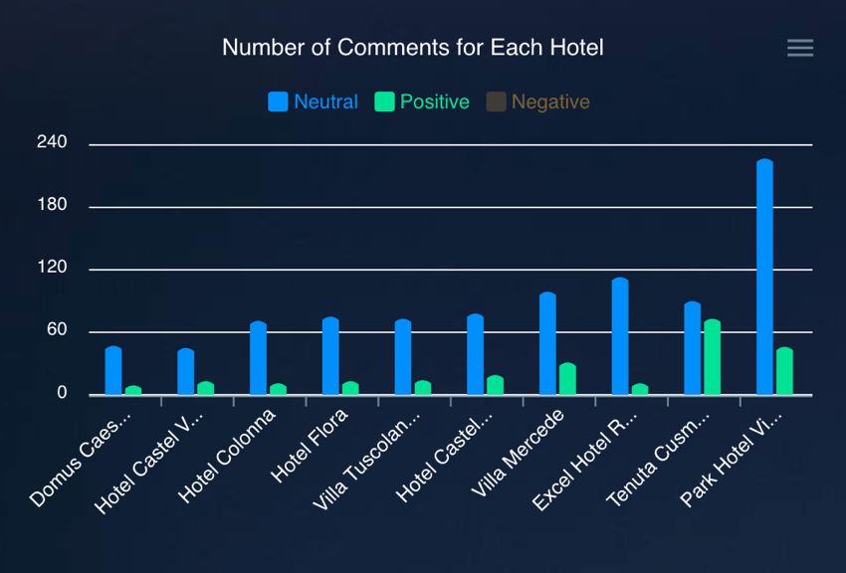

Figure : View the comments by sentiment3

This page is using for admin to view comments by sentiment, the page consists of:

1. “Neutral” legend for showing the neutral comments column.
2. “Positive” legend for showing the positive comments column.
3. “Negative” legend for showing the negative comments column.
4. Data showing with each hotel name.

# 6. List of Figures

Figure 1: System Architecture 9

Figure 2: Component Diagram 12

Figure 3: Class diagram 13

Figure 4: App class 15

Figure 5: Home class 16

Figure 6: Register class 18

Figure 7: Login class 20

Figure 8: AdminLogin class 23

Figure 9: Admin class 24

Figure 10: Accounts class 27

Figure 11: Dashboard class 29

Figure 12: User Profile class 32

Figure 13: Edit Profile class 34

Figure 14: Summary class 39

Figure 15: SparkLine class 40

Figure 16: LineChart class 43

Figure 17: BarChart class 45

Figure 18: StackedChart class 47

Figure 19: DataService class 49

Figure 20: UserService class 53

Figure 21: Mongo class 56

Figure 22: DataProvider class 63

Figure 23: Log class 68

Figure 24: Hotel class 70

Figure 25: View class 73

Figure 26: HeatMap class 75

Figure 27: Word-Cloud class 77

Figure 28: ER Diagram 79

Figure 29: Sequence Diagram 80

Figure 30: Sequence Diagram 82

Figure 31: Sequence Diagram 84

Figure 32: Sequence Diagram 86

Figure 33: Sequence Diagram 87

Figure 34: Sequence Diagram 88

Figure 35: Homepage UI 89

Figure 36: Super admin login UI 90

Figure 37: Register UI 91

Figure 38: Admin Login UI 92

Figure 39: Add accounts UI 93

Figure 40: Dashboard UI 94

Figure 41: User profile page UI 95

Figure 42: Edit username page UI 96

Figure 43: Edit password page UI 97

Figure 44: All users view comments UI 98

Figure 45: Admin writes comments UI 99

Figure 46: Super admin views system log UI 100

Figure 47: View the word-cloud of data 101

Figure 48: View the heatmap of data. 102

Figure 49: View the comments by sentiment1 103

Figure 50: View the comments by sentiment2 103

Figure 51: View the comments by sentiment3 104